Constructing the bitcoin market potential index:

A principal component analysis approach

University of Nottingham Malaysia Campus

Bachelor of Science in Economics

Constructing the Bitcoin Market Potential index: A Principal Component Analysis Approach

Bernard Tan Chik Shyan

April 20, 2018

(7459 words)

**Abstract:**

In this paper Bitcoin Market Potential Index (BMPI) is defined as the total potential utility gained in a country by adopting bitcoin in all means. This index reports usefulness of bitcoin across 178 countries. The data includes eight dimensions and nineteen sub variables. The BMPI is computed using two different weighting schemes, namely the Equal Weighted(EW) and Principal Component Analysis(PCA). The result of both indices is then compared with the Hileman’s BMPI. There exists a statistically significant and positive correlation between BMPI under Principal Component Analysis and GDP per capita in logarithmic scale at 5% significance level which null hypothesis cannot be rejected.

**Acknowledgments**

First, I would like to express my heartfelt gratitude to my family, who has given me moral support and meaningful life advices. I would like to thank my classmates, Yee Hui for helping me in collection of data. I would want to express gratitude to my advisor, Dr. Muhammad Shafiullah for giving me freedom to pursue and write about the topic that I love. Lastly, thanks to everyone in my life, which have helped make the person I am today. I could not be more thankful.

Table of Contents

Introduction and background 4

Literature Review 8

Conceptual Framework of BMPI Variables 11

Data sources and Limitations 18

Index Methodology 20

Results 24

Conclusion 48

References 49

Appendix A: Hileman’s BMPI Ranking in 2014 using Equal Weighting (EW) 51

Appendix B: BMPI in 2018 using Equal Weighting (EW) 55

Appendix C: BMPI in 2018 using Principal Component Analysis (PCA) 59

**1 Introduction and Background**

1.1The Birth of Bitcoin and its Mechanism Design

“The one thing that’s missing but that will soon be developed is a reliable e-cash, a method whereby on the internet you can transfer funds from A to B without A knowing B or B knowing A. The way in which I can take a twenty-dollar bill and hand it over to you and there is no record of where it came from and you may get that without knowing who I am.” - Milton Friedman, interviewed in 1999.

Although the latter part of this quote was not so accurate to account for the pseudonomity[1] nature of Bitcoin, the late Nobel Laureate in Economics Milton Freidman was close enough to predict the birth of cryptocurrency such as Bitcoin.

In the wake of global recession in 2008 primarily caused by financial deregulation and the greediness of banking industry, Satoshi Nakamoto, whose identity is still unknown, had published the white paper for Bitcoin titled “Bitcoin: A Peer-to-Peer Electronic Cash System”. Although this paper is merely nine pages long, it has garnered a lot of attention from media and public as it provides a solid solution to the infamous double spending problem. Unlike other digital currencies existed before, Bitcoin represents itself as the first cryptocurrency that is able to overcome counterfeiting issue by using cryptographic proof without the involvement of third party.

Despite having a fancy name of Bitcoin, it is not an entirely novel technology invented by Satoshi Nakamoto. In fact, the core idea in Bitcoin is a combination of several technologies existed in the past. However, Bitcoin is the first to combine them altogether and comes out with this unique architecture design. For example, the cryptographic hash function, which is one of the integral parts constituting Bitcoin, was being invented in the 1990s. This Proof of Work (PoW) system and other existing concepts- such as merkle trees, Peer-to-peer network and cryptographic signatures has enabled Satoshi to invent the Blockchain, which is basically the digital distributed ledger based on trustless consensus mechanism.

The main idea of Prove of work (PoW) system is that, in order to be allowed to add a block to the blockchain, the creator of the block has to put in some effort for it. The proof needs to be easy to be proved yet hard to be generated to prevent hacking by brute force. In the case of Bitcoin, the miner gets rewarded with bitcoins for the computational power he puts in to solve cryptographic problem. By solving the cryptographic problem, miners build and maintain the public ledger also known as blockchain containing a record of every bitcoin transaction since the primordial block #0 mined by Satoshi himself.

1.2 Background

In lights of the skyrocketing price of Bitcoin and massive potential of blockchain applications in changing faces of financial industries, cryptocurrency has been reported widely among the mass media for public interest. The perspective of governments also has changed over time, from being disinterested to planning to regulate bitcoin as part of financial world. However, as most countries are still considering ways to impose guidelines for cryptocurrencies, some countries have taken solid actions against bitcoin. For example, Japanese legislature has passed a law recognizing Bitcoin as a form of legal tender. On the other end of the spectrum, we have countries like Bangladesh and Iceland which outright banned Bitcoin as an illegal form of payment. Nonetheless, these news about government regulations seem to have minimal effect to Bitcoin price index, as the bullish market keeps pushing price to a new high.

From the viewpoint of citizens, as some think that the creation of Bitcoin is a an irrational exuberance, people with high hopes on this growing digital currency think that it can be a catalyst for new economy. Indeed, Bitcoin’s design as a decentralized peer-to-peer currency provides an innovative way of payment without the involvement of intermediary party. Unlike the traditional payment existed, Bitcoin has the potential to provide a more secured and private payment to others without the acknowledgments of third party. In essence, it can be simplified as a mean of money disintermediation and decentralization. Furthermore, the transaction fee can be significantly smaller and the transaction processing time can be faster with the technological breakthrough of lightning network and SegWit scaling. This monumental achievement has opened up a whole new world for financial banking system and remittance industry.

In contrast, the eruption of global financial crisis in 2008 had crushed the investor confidence and bank reputation. The currency crises and hyperinflation faced by countries like Venezuela, Zimbabwe and Bolivia have rendered their fiat currencies worthless. Subsequently, these currencies cannot be relied upon to act as disaster asset especially when the period of political instability strikes. Combining all the factors discussed, it is unsurprising that people start to consider cryptocurrency especially bitcoin as either mean of payment or part of their investment portfolio diversification.

However, despite the growing number of transaction volumes and bitcoin users as a whole, financial institutions and venture capitalists find it difficult to determine which international markets to invest and the appropriate investing strategies due to pseudonymous nature of Bitcoin. It is also proved challenging for governments and policy makers to enact sound administrative measure for bitcoin.

Thus, concerning the rising importance of cryptocurrency in the global economy and its potential mass adoption amongst nations, this paper focuses on constructing a country ranking index based on usefulness and potential utility of cryptocurrency brought to the market. This index aims to provide policy makers with insights on own strengths and weaknesses, while identifying the countries where the cryptocurrency market may prosper.

**2. Literature Review**

Crypto-finance world is a field filled with enticing prospects as it seems promising in many ways to challenge the incumbent banking and monetary system. It has gained a lot of attraction from investors and venture capitalist as more than 2.5 billion U.S dollars is being invested in terms of blockchain venture and Initial Coin Offering (ICO) in merely few years. In contrast, there is a minimal number of economics research regarding cryptocurrency. However, the amount of literature has been steadily increasing. As the rapid explosion of bitcoin in term of popularity and price continues, it is expected that more academic papers will be produced to expand knowledge in the field of cryptocurrency.

The main economic research in this field can be divided into three categories, which are 1) characteristics and nature of bitcoin, 2) volatility and pricing formation of bitcoin, and 3) application of bitcoin in real world cases. As one might notice, most findings are revolving around Bitcoin. At the time of writing, Bitcoin is the world’s largest cryptocurrency in terms of market capitalizations and trade volume, followed by the alternative currencies (altcoin) like Ethereum, Ripple Coin, Dash and Litecoin. Thus, it is inevitable to generalize cryptocurrency as bitcoin on account of discussion in our context due to its incomparable influence.

Regarding the nature of Bitcoin, there has been a long debate discussing about what bitcoin should be. Theoretically speaking, Bitcoin can be seen as money from the view of Austrian economics although it does not fulfill the Mises’ regression theorem. (Mazer, 2015) Some argues that it should be a mean of payment while others argue that it should act as store of value. In the papers written by Baur, Hong and Lee (2017) and Yermack (2014), it is concluded that Bitcoin is used mainly as a speculative asset. On the other hands, Bohme (2014) had analyzed the plausibility of bitcoin as peer-to-peer payment and concluded that bitcoin is superior than current international payment system in aspects of capability, cost and speed.

There is a growing literature about the volatility and pricing formation of Bitcoin. Ciaian et al. (2014) studied the relationship between Bitcoin price and supply-demand fundamentals, global macro-financial indicators and Bitcoin’s attractiveness for investors. The study finds out that the macro-financial indicators are statistically insignificant for Bitcoin price formation. Soldevilla (2017) concluded that there exists a bidirectional Granger-causality relationship between Bitcoin realized volatility and the CBOE Volatility Index (VIX) at 5% significance level. Davies (2014) summarized that changes in Google Trends of Bitcoin and Bitcoin price volatility affect each other.

As the awareness of bitcoin increases, more research is carried out to investigate the potential role of bitcoin in real life cases. In the paper written by Moore and Stephen (2015), Bitcoin is examined empirically to be part of international reserves in the case of Barbados. The result shows that Bitcoin has the potential to become key currency for transaction purposes and Central Bank of Barbados should hold a proportion of reserves in Bitcoin to avoid speculative attack. D’Alfonso and his colleagues (2016) examines the ideal investment strategy of including both Bitcoin and Ethereum into one’s portfolio.

The objective of this paper is to improve on measure of Bitcoin utility ranking by countries done by Hileman (2014). This paper is the first attempt to produce the Bitcoin Market Potential Index (BMPI) that ranks bitcoin’s potential utility across 178 countries. While this index has provided a good framework for future reference and better understanding of the factors behind bitcoin adoption, the writer acknowledged that there is certain limitation due to insufficient data and ambiguous effect brought by regulations. Others than that, this paper missed out the variables that estimate the influence of political situation on Bitcoin adoption. Viglione (2015) investigated the case of Bitcoin as a possible disaster asset that can be used for diversification across jurisdictions with minimal costs, which suggesting that cryptocurrencies can behave as disaster assets for those in politically instable environments.

In essence, this paper aims to fill the gap left by works described above by constructing a more comprehensive bitcoin market potential index by using Principal Components Analysis. This paper also represents the first attempt to produce BMPI using dimension reduction method. We add in one sub-index, namely the political instability index and few variables which had insufficient data in the past. In the hope of answering the topic given, the results of the newly derived index will be compared with the Hileman’s work, and then do country case studies to examine the relevance of our index in real-world basis. A correlation analysis will be carried out between the newly derived BMPI and GDP per capita to assess the association between income and likelihood of using bitcoin.

**3. Conceptual framework of BMPI variables**

Bitcoin is an interdisciplinary field situated itself at the intersection of social, political, technological and economic aspects. Hence, the selection of variable to construct Bitcoin Market Potential Index (BMPI) should be interdisciplinary as well. The variables discussed below are the eight dimensions representing different aspects where bitcoin can be useful.

3.1 Inflation

Inflation is another issue where Bitcoin is able to set in. While mild inflation is generally healthy to the economy, high inflation can erode the real income of labor. Subsequently it causes loss of confidence in domestic currency. As Bitcoin is a currency with finite supply like gold and silver, it is attractive to people in countries with high inflation level to invest in or even adopt it as alternative to fiat currency. Thus, we concur that bitcoin utility is positively correlated with inflation rate and create an independent sub index based on inflation.

3.2 Informal Economy

“Shadow economy is a perennial, multifaceted and hard to gauge phenomenon that affects to some degree all countries.”  *—A new multidimensional ranking of shadow economy for EU countries*

Given the evasive nature of informal economy, it is very difficult for the authority to regulate or even monitor these non-law-abiding activities. According to Medina and Schneider (2017), the shadow economy or black market includes all economic activities which are hidden from official authorities for monetary, regulatory or institutional reasons. Based on this definition, we quantify the extent of informal economy by mostly using the dataset provided in their paper. In this context, we measure the size of informal economy as percentage of total economy.

Due to pseudo anonymity characteristic of Bitcoin, it is attractive for people who wish to circumvent government law or surveillance to adopt Bitcoin as mean of payment. However, this attribute has also attracted a lot of early adopters who are interested in illegal drug trade. One of the most prominent example is the misuse of bitcoin in Silk Road in early 2010s. Nonetheless, we argue that cryptocurrency brings more good than harm, as ethical use of cryptocurrency can potentially promote financial inclusion for those unbanked and underbanked households in countries with large underground economies.

3.3 Remittance

According to World Bank forecast in 2017, it is estimated that the total remittance flows to the developing countries would be a staggering amount of 444 billion dollar. The real figure could be much higher considering the informal cross border money transfer channels such as hawala system in Middle East is not being calculated. The remittance is an important lifeline to many third world countries as it promotes economic growth and poverty reduction immensely. (Pradhan et.al, 2017)

However, sending an international money transfer often comes with listed transfer fee and a hidden fee. The hidden fee is the foreign exchange markup, which represents the difference between generating quotes of the consumer exchange rate and the real-time market exchange rate. According to a survey research conducted by finder.com, the average exchange rate margin is 1.84% and this would result in estimated $8.17 billion spent annually in unknown fees.

While the trend in decreasing costs of remittance service worldwide continues, some regions are still benefited relatively less from it. The obvious example would be the Latin-American and Sub-Saharan regions, where the remittance cost is the highest among all.

With the emergence of blockchain technology, transferring money across the border through bitcoin can potentially disrupt the businesses of remittance companies such as Western Union, WorldRemit and MoneyGram. While the people spend 31.7 billion US dollar per year in fees to send money back home to relatives, bitcoin can provide an option for expatriates and foreign workers to remit their incomes quicker and cheaper.

As Bitcoin-based remittance startups can be useful for remittance market especially the niche one that is often neglected by big enterprises, data offered by world bank is used to measure utility of bitcoin in remittance. This sub index shall include both average remittance fee and personal remittance received by country. The personal remittance variable is further divided into two components, which are personal remittance by US dollar and personal remittance as percentage of GDP. This classification is necessary to recognize the importance of remittance to the country development.

3.4 Technology penetration

Technology penetration is defined as “the rate at which a specific technical innovation becomes adopted into the everyday life of individuals within a social group.” (Encyclopedia of Information Technology Curriculum Integration) Based on this definition, three equally weighted components under this sub index are included. The first component rates the number of internet users per hundred people. The second component consists of number of mobile cellular subscription per hundred people while the last component calculates the number of fixed broadband subscriptions per hundred people. These components altogether provide an imperfect but still practical proxies to measure the internet coverage among citizens in certain country.

Although bitcoin transaction can be done offline using text message service and blockchain specialized satellite, online bitcoin transaction is still the most popular way of receiving and sending bitcoin. Lack of internet access can therefore impede the process of bitcoin adoption.

3.5 Financial Crises

As financial crises take a wide array of forms, Hileman (2014) categorizes it into four equally weighted variables: hyperinflation, currency crises, inflation crises and other crises episodes. The other crises episodes variable is further divided into external default, domestic default and banking crises.

As the number of financial crises increases in the country, it is logical that the citizens would gradually lose trust in the national currency for the failure of government to correct the market. Theoretically, this phenomenon will translate in the adoption of cryptocurrency.

3.6 Financial repression

Another financial aspect that will may realize mass adoption in bitcoin is economic repression.

According to Viglione (2015), countries which experience higher degree of price manipulation, greater trade barrier, stricter capital control or lack of independence in financial institution from government would be the prime candidates for bitcoin adoption. In essence, people in countries with higher than average economic repression now have an alternative way of transmitting funds out of currencies that are at risk of losing significant value through converting fund into cryptocurrencies.

In this context, Hileman’s concept is used to construct financial repression sub index. It includes twelve equally weighted variables and seven sub-variables for the case of financial sector repression. The details of each variables are available in Hileman’s paper and the appendix of this paper.

3.7 Bitcoin penetration

Bitcoin penetration index rates the exposure and awareness of bitcoin among public. This is reflected by five variables, which are global bitcoin nodes, bitcoin software client downloads, google ‘bitcoin’ search ranking, bitcoin VC investment and lastly, ease of using bitcoin in daily life sub-index. “Per capita” concept is applied in sub-variables to show relative bitcoin adoption between countries.

Notably, one of the most distinctive features in this paper compared with Hileman’s paper is the introduction of “ease of using bitcoin in daily life” sub-index. This variable is useful in measuring the convenience of using bitcoin in acquiring good and services in daily basis. This variable involves combination of number of bitcoin auto teller machine (ATM) and number of merchant accepting bitcoins as payment by country. “Per square kilometer of land area” concept is applied to provide a better approximation of bitcoin merchant density.

3.8 Political repression

Viglione (2015) stated in his paper that *“… investors undergo a higher than normal degree of asset confiscation with limited legal ability to protect themselves by moving funds outside of the local currency, or political jurisdiction.*” This statement presents potential utility of Bitcoin as Bitcoin is arguably one of the best way to pass fund internationally effectively without government interference.

Viglione elaborated further about the possibility of Bitcoin acting as a disaster asset in politically instable markets. The result of his paper has enabled the inclusion of political aspect in the BMPI. Hence the political stability index conducted by World Bank is included as one of the sub indices. The component should be self-explanatory as Bitcoin is most likely to be adopted in the least political stable countries.

**4. Data sources and limitations**

As the research aims to encompass as many dimensions as possible, a wide range of data is required to construct the variables for social, economic, political and technological aspects. This latest BMPI consists of all variables used by Hileman and newly added 2 variables which are deemed important. Most of the variables has been updated except for Financial Crises and Financial Repression variables due to data constraints. Thus, Hileman’s rankings for both variables are used as the proxy data.

The data for variables is collected from various sources that are deemed trustable. They are mainly from Google Trends, IMF, CoinDesk and World Bank. Secondary data from the work of Reinhart and Rogoff (2010) and Hassan and Schneider (2016) are used. Reinhart and Rogoff provide the data for financial crises index while the paper of Hassan and Schneider has the latest dataset regarding shadow economy in 157 countries. A decision is made to choose this paper over Elgin and Oztunali’s paper in 2012 as the former provides more recent data. However, Elgin and Oztunali’s paper is used to complement some unavailable data in this context.

In order to include political factor in the index, ranking data from World Bank’s Political Stability Index is used. Furthermore, number of merchant adoptions and Bitcoin ATM are being included in the “Bitcoin Penetration” sub-index. These data were previously unavailable but now one can get access to these information from the Coinmap.org or Coinatmradar.com.

A further effort is made to manually count and record 10731 sites around the world that accept bitcoin payment.

As this paper aims to assess utility of bitcoin adoption on a global scale, an effort is made to include all relevant indicators for 178 countries. Nonetheless, problems arise inevitably due to insufficient data, especially in developing countries. For example, as mentioned by Hileman, while smartphone penetration data can be served as a more accurate variable for Technology penetration sub-index, the study conducted by Newzoo only reported for data of 50 countries in 2017. Other than that, the cultural dimension is not being included as there is insufficient research working on this topic. However, it is possible to identify the factors having an impact on the adoption of the bitcoin currency by using the Unified Theory of Acceptance and Use of Technology 2 (UTAUT2). It is particularly interesting in understanding how different culture influence the adoption of a new technology by using this theoretical framework.

In order to solve cases of data inadequacy, several alternative sources such as KNOEMA company, CIA Factbook and Western Union are used to fill in the blanks of missing data. KNOEMA is a privately held company that specializes in data research while CIA Factbook provides resources contributed by Central Intelligence Agency of United States. Their data serve as substitute for the missing country level data of World Bank. As Western Union remains its position as the leader in remittance market, their data can serve as a proxy approximating the Remittance Sub-index.

As conclusion, this index has compiled data from multiple sources, including national statistics bureau, non-governmental organization, academic resources and corporations.

**5. Index Methodology**

“What is badly defined is likely to be badly measured.” – OECD Handbook on Constructing Composite Indicators.

5.1 Defining BMPI

As there is no existence of theoretical framework regarding this topic, defining the term “Bitcoin Market Potential Index” (BMPI) is based on subjective evaluation. In this paper, it is defined as the total potential utility gained in a country by adopting bitcoin in all means. Thus, the scenarios of adopting bitcoin shall not just be constrained by replacement of local fiat currency. It can be the scenario where people adopt bitcoin by their own, thus forming a shadow economy, or the scenario where bitcoin becomes a parallel currency. BMPI also captures the possibility that country decides to make their own cryptocurrency, as long as the cryptocurrency has the similar characteristics with bitcoin. Additionally, most of the subsequent cryptocurrencies are based on the Bitcoin protocol and are variations on the same principle. Thus, studying Bitcoin will provide an accurate representation on the overall dynamics of cryptocurrencies.

As Bitcoin continues its dominance over the other cryptocurrencies such as Ripple, Ethereum and Litecoin, BMPI shall work as proxy in finding which country is conducive to adoption of cryptocurrencies as a whole.

5.2 Selecting the variables

Next, due to the interdisciplinary nature of Bitcoin, the variables should be carefully chosen from four aspects for their implications on bitcoin adoption, which are politics, social, technology and economy aspects. These variables can be categorized into eight dimensions, which are inflation, shadow economy, remittances, technology penetration, financial crisis, financial repression, bitcoin penetration and political instability.

5.3 Imputation of Missing Data

Several imputation methods are carried out in BMPI data construction. It includes substitution, hot-and-cold-deck imputations and unconditional median imputation. Case deletion is neglected in this context because the omission of missing records from analysis may lead to bias and make comparison between countries impossible.

5.4 Index variable weighting

There are a number of weighting technique to construct the index, such as Equal Weighting (EW), Factor Analysis (FA) and Principal Component Analysis (PCA). Hileman has used Equal Weighting techniques in his BMPI research in 2014. For example, if the variable under a dimension has *10%* weight, then the *n* number of sub-variables would share the weight of $\frac{10}{n}\%$ each. This method is relatively simple to apply, and it implies that the impact is the same across all dimensions. However, one may encounter the problem of double counting if the variables are highly correlated to each other.

Thus, in order to group individual indicators according to their degree of correlation, alternative weighting scheme by using Principal Component Analysis (PCA) was carried out in this paper. This paper also represents the first attempt of constructing BMPI by using a statistical model. PCA method is useful in variable reduction as it accounts for the highest possible variation in the indicator set using the smallest possible number of factors. The factors scores by sub-indices can be aggregated into the final BMPI by weighting each factor according to its relative contribution to the explanation of the overall variance of the factor used. Unlike equal weighting scheme, this approach is objective and depends on the proportion of explained variances.

In this paper, *standardization (z-score)* is used to rescale data into common scale before constructing the indices based on both Equal Weighted (EW) and Principal Component Analysis (PCA). Kaiser-Meyer-Olkin (KMO) measure of sampling adequacy and Bartlett’s test of sphericity are used to measure the suitability of data for PCA prior to the practice.

$$I_{qc}^{t}=\frac{x_{qc}^{t}-\min_{c}(x_{q}^{t})}{\max_{c}\left(x_{q}^{t}\right)-\min_{c}(x_{q}^{t})}$$

$x_{qc}^{t}$: raw value of individual indicator at time *t* for country *c*,

$\overline{c}$**:** average ${ x}_{qc}^{t}$ across countries

$I_{qc}^{t}$: standardized value of individual indicator at time *t* for country *c*

$σ_{qc=\overline{c}}^{t}:$ standard deviation across countries at time *t*

Decomposition analysis shall be made to further examine the index by graph visualization. And lastly, the robustness of BMPI shall be assessed by using uncertainty analysis. This analysis involves the process of comparing the results of BMPI using different weighting schemes (PCA and EW). Comparison with Hileman’s BMPI is made as reference to the index construction using Equal Weighted method.

Last but not least, the relationship between the BMPI index and Gross Domestic Product (GDP) related variable, namely GDP per capita is being investigated by plotting a scatter diagram. These variables are logarithmically transformed to reduce magnitude of data. The variables of sub-index using GDP measurement such as Size of Shadow Economy as percentage of economy and Proportion of Personal Remittances received in economy are removed prior to the analysis. Finally, correlation analysis between the variables is done by conducting different correlation tests.

**6. Results**

Table 1 shows the top 10 countries with the highest relative potential for bitcoin adoption according to Bitcoin Market Potential Index. The ranking from year 2014 is derived from the Hileman’s paper while the ranking of 2018 is the result of this paper.

|  |  |  |
| --- | --- | --- |
| BMPI ranking (Equal Weighting Method) | | |
| Year | 2018 | 2014 (Hileman) |
| Ranking | Country Name | Country Name |
| 1 | Venezuela, RB | Argentina |
| 2 | Congo, Dem. Rep. | Venezuela |
| 3 | Ukraine | Zimbabwe |
| 4 | Nigeria | Malawi |
| 5 | Mozambique | United States |
| 6 | Argentina | Belarus |
| 7 | Suriname | Nigeria |
| 8 | Zimbabwe | Congo, Dem. Rep. |
| 9 | Thailand | Iceland |
| 10 | Turkey | Iran |

(Table 1)

By using the same methodology of equal weighting, a comparison is made between Hileman’s ranking and newly derived BMPI. The observation is that 5 countries which are Venezuela, Congo, Dem. Rep., Nigeria, Argentina and Zimbabwe have continued to stay in top 10 positions after 4 years. There is also new entry of countries in the top 10 ranking, which are Ukraine, Mozambique, Suriname, Thailand and Turkey. Among these countries, Thailand is the only South East Asian country in the top 10 ranking and shows great improvement from 52th to 9th. In contrast, Iran dropped from 10th to 81th in the latest ranking. The reason can be found in the decomposition analysis when we look into scoring of sub-index. Compared with 2014, Iran ranks lower in all aspects except for technology penetration. Thailand has ranked higher in all aspects except for inflation and bitcoin penetration score. Its rank at 61th in remittance score compared with 155th in 2014 has boosted its overall BMPI immensely.

Next, the result between top 10 country rankings of BMPI using different weighting methods (EW and PCA) is shown in the table 2.

|  |  |  |
| --- | --- | --- |
| BMPI ranking 2018 | | |
| Methods | Equal Weighted | Principal Component Analysis |
| Ranking | Country Name | Country Name |
| 1 | Venezuela, RB | United States |
| 2 | Congo, Dem. Rep. | Germany |
| 3 | Ukraine | Netherlands |
| 4 | Nigeria | China |
| 5 | Mozambique | Venezuela, RB |
| 6 | Argentina | United Kingdom |
| 7 | Suriname | France |
| 8 | Zimbabwe | Singapore |
| 9 | Thailand | Sweden |
| 10 | Turkey | Canada |

(Table 2)

Except for Venezuela, the remaining countries are all different between both rankings. Most countries in the top 10 BMPI ranking using EW method come from Sub-Saharan and Latin American Regions, while developed and high-income countries scored higher in the right-hand side ranking by PCA method. This reflects that the different weighting schemes have considerable impact on the construction of BMPI. A further analysis on the component scores of BMPI using Principal Component Analysis is needed to clarify and explain its differences compared with Equal Weighted method.

6.1 Process of constructing BMPI using PCA

Multivariate Analysis by using Principal Components Analysis

The objective of using PCA technique is to reveal how different variables change in relation to each other and explain the variance through a few linear combinations of data. Prior to the analysis, the data were standardized first to have zero mean and unit variance.

|  |  |  |  |
| --- | --- | --- | --- |
| **Descriptive Statistics** | | | |
|  | Mean | Std. Deviation | Analysis N |
| Zscore(Inflation) | .0000000 | 1.00000000 | 178 |
| Zscore(ShadowEconomy) | .0000000 | 1.00000000 | 178 |
| Zscore(RemittancePrice) | .0000000 | 1.00000000 | 178 |
| Zscore(Remittance) | .0000000 | 1.00000000 | 178 |
| Zscore(RemittanceGDP) | .0000000 | 1.00000000 | 178 |
| Zscore(InternetUser) | .0000000 | 1.00000000 | 178 |
| Zscore(MobileSub) | .0000000 | 1.00000000 | 178 |
| Zscore(FixedBroadband) | .0000000 | 1.00000000 | 178 |
| Zscore(FinancialCrises) | .0000000 | 1.00000000 | 178 |
| Zscore(FinancialRepression) | .0000000 | 1.00000000 | 178 |
| Zscore(Nodes) | .0000000 | 1.00000000 | 178 |
| Zscore(NodesPercapita) | .0000000 | 1.00000000 | 178 |
| Zscore(Software) | .0000000 | 1.00000000 | 178 |
| Zscore(SoftwarePercapita) | .0000000 | 1.00000000 | 178 |
| Zscore(GoogleSearch) | .0000000 | 1.00000000 | 178 |
| Zscore(VCFunding) | .0000000 | 1.00000000 | 178 |
| Zscore(Merchantsnum) | .0000000 | 1.00000000 | 178 |
| Zscore(MerchantnumLand) | .0000000 | 1.00000000 | 178 |
| Zscore(PoliticaIInstability) | .0000000 | 1.00000000 | 178 |

|  |  |  |
| --- | --- | --- |
| **KMO and Bartlett's Test** | | |
| Kaiser-Meyer-Olkin Measure of Sampling Adequacy. | | .794 |
| Bartlett's Test of Sphericity | Approx. Chi-Square | 1985.264 |
| df | 171 |
| Sig. | .000 |

Kaiser-Meyer-Olkin (KMO) and Bartlett’s Test of Sphericity were used to test the suitability of data for Factor Analysis purpose. The value of KMO is stated as 0.794 while the P-value of smaller than 0.05 is significant enough to reject the null hypothesis. Therefore, Principal Components Analysis should be carried out as there are intercorrelations between individual

indicators.

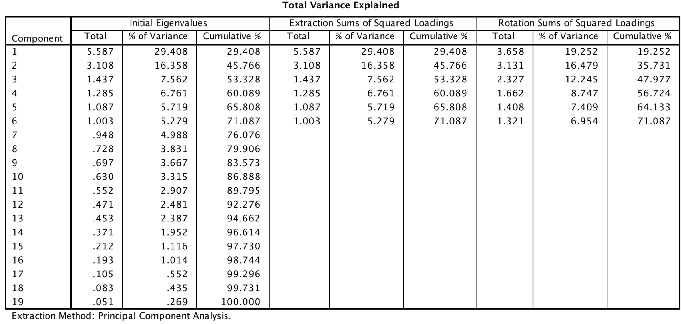

(Table 3)

The table 3 shows the eigenvalues of the correlation matrix of the 19 individual indicators that compose BMPI. The factors with associated eigenvalues larger than one are chosen. Thus, a total of 6 factors is seleted and the factors are accounted for 71.09% of overall variance. The scree plot serves as visualization of factors associated with eigenvalues.

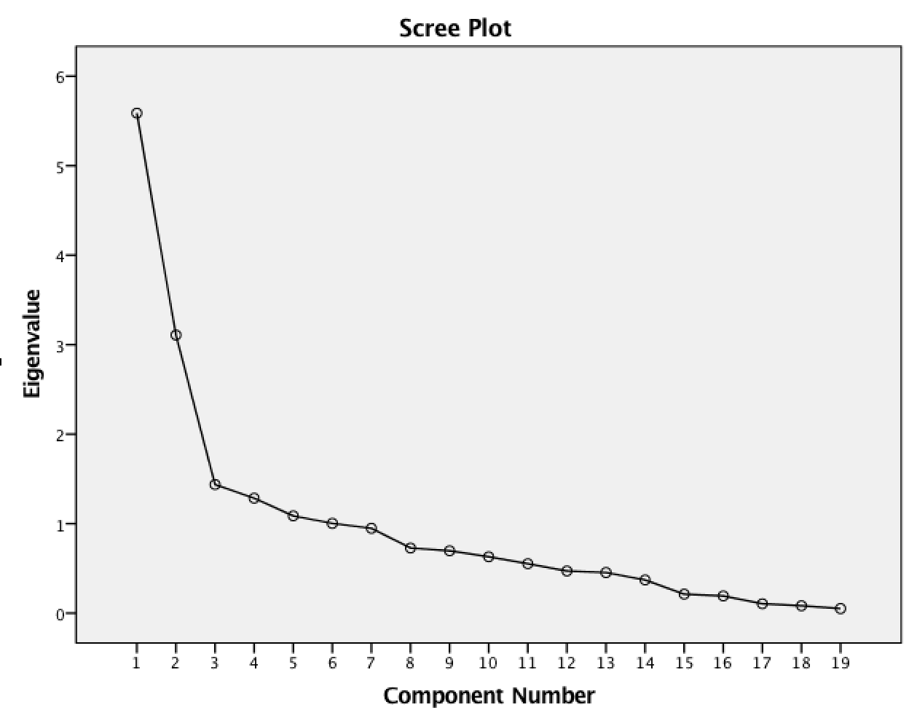

|  |  |  |  |  |  |  |
| --- | --- | --- | --- | --- | --- | --- |
| Rotated Factor Loading | | | | | | |
|  | Component | | | | | |
| 1 | 2 | 3 | 4 | 5 | 6 |
| Zscore(Software) | .952 | .070 | .105 | .015 | -.009 | .131 |
| Zscore(VCFunding) | .949 | .019 | .005 | -.017 | -.044 | -.032 |
| Zscore(Merchantsnum) | .916 | .165 | .092 | -.001 | .048 | -.002 |
| Zscore(Nodes) | .903 | .081 | .115 | .129 | -.028 | .128 |
| Zscore(InternetUser) | .087 | .804 | .431 | .148 | -.080 | .097 |
| Zscore(MobileSub) | -.038 | .721 | .112 | -.023 | -.198 | .103 |
| Zscore(FinancialRepression) | -.154 | -.690 | .059 | -.116 | .036 | .160 |
| Zscore(FixedBroadband) | .194 | .673 | .430 | .346 | -.041 | .022 |
| Zscore(SoftwarePercapita) | .199 | .562 | .428 | .389 | .036 | -.140 |
| Zscore(PoliticaIInstability) | -.024 | -.484 | -.336 | -.236 | .334 | .366 |
| Zscore(RemittanceGDP) | -.052 | -.102 | -.716 | .038 | -.152 | .046 |
| Zscore(ShadowEconomy) | -.153 | -.272 | -.667 | -.131 | .130 | -.186 |
| Zscore(GoogleSearch) | .088 | .231 | .578 | .331 | -.206 | -.069 |
| Zscore(MerchantnumLand) | -.059 | .045 | .010 | .831 | -.163 | .025 |
| Zscore(NodesPercapita) | .131 | .315 | .200 | .673 | .078 | -.036 |
| Zscore(FinancialCrises) | .028 | -.037 | -.178 | -.089 | .789 | .040 |
| Zscore(Inflation) | -.046 | -.169 | .142 | -.010 | .700 | -.010 |
| Zscore(Remittance) | .168 | -.141 | .143 | -.018 | -.022 | .831 |
| Zscore(RemittancePrice) | -.021 | -.398 | .455 | -.048 | -.115 | -.594 |

|  |  |  |  |  |  |  |
| --- | --- | --- | --- | --- | --- | --- |
| Rotated Squared Factor Loading (scaled to unity sum) | | | | | | |
|  | Component | | | | | |
| 1 | 2 | 3 | 4 | 5 | 6 |
| Zscore(Software) | **0.25** | 0.00 | 0.00 | 0.00 | 0.00 | 0.01 |
| Zscore(VCFunding) | **0.25** | 0.00 | 0.00 | 0.00 | 0.00 | 0.00 |
| Zscore(Merchantsnum) | **0.23** | 0.01 | 0.00 | 0.00 | 0.00 | 0.00 |
| Zscore(Nodes) | **0.22** | 0.00 | 0.01 | 0.01 | 0.00 | 0.01 |
| Zscore(InternetUser) | 0.00 | **0.21** | 0.08 | 0.01 | 0.00 | 0.01 |
| Zscore(MobileSub) | 0.00 | **0.17** | 0.01 | 0.00 | 0.03 | 0.01 |
| Zscore(FinancialRepression) | 0.01 | **0.15** | 0.00 | 0.01 | 0.00 | 0.02 |
| Zscore(FixedBroadband) | 0.01 | **0.14** | 0.08 | 0.07 | 0.00 | 0.00 |
| Zscore(SoftwarePercapita) | 0.01 | **0.10** | 0.08 | 0.09 | 0.00 | 0.01 |
| Zscore(PoliticaIInstability) | 0.00 | 0.07 | 0.05 | 0.03 | 0.08 | **0.10** |
| Zscore(RemittanceGDP) | 0.00 | 0.00 | **0.22** | 0.00 | 0.02 | 0.00 |
| Zscore(ShadowEconomy) | 0.01 | 0.02 | **0.19** | 0.01 | 0.01 | 0.03 |
| Zscore(GoogleSearch) | 0.00 | 0.02 | **0.14** | 0.07 | 0.03 | 0.00 |
| Zscore(MerchantnumLand) | 0.00 | 0.00 | 0.00 | **0.42** | 0.02 | 0.00 |
| Zscore(NodesPercapita) | 0.00 | 0.03 | 0.02 | **0.27** | 0.00 | 0.00 |
| Zscore(FinancialCrises) | 0.00 | 0.00 | 0.01 | 0.00 | **0.44** | 0.00 |
| Zscore(Inflation) | 0.00 | 0.01 | 0.01 | 0.00 | **0.35** | 0.00 |
| Zscore(Remittance) | 0.01 | 0.01 | 0.01 | 0.00 | 0.00 | **0.52** |
| Zscore(RemittancePrice) | 0.00 | 0.05 | 0.09 | 0.00 | 0.01 | **0.27** |

(Table 4)

The table 4 above shows the rotated squared factor loading after being scaled to unity sum. Each value in the column adds up to value of 1. The number figures in bold font belongs to the individual indicators with the highest factor loadings. These individual indicators in each component are then grouped into intermediate composite indicators. By applying this method, 6 intermediate composite indicators are grouped as shown in table 6.

|  |  |  |  |  |  |  |
| --- | --- | --- | --- | --- | --- | --- |
| Rotated Squared Factor Loading and Weightage for Each Factor | | | | | | |
|  | Component | | | | | |
| 1 | 2 | 3 | 4 | 5 | 6 |
| Zscore(Software) | .91 | .00 | .01 | .00 | .00 | .02 |
| Zscore(VCFunding) | .90 | .00 | .00 | .00 | .00 | .00 |
| Zscore(Merchantsnum) | .84 | .03 | .01 | .00 | .00 | .00 |
| Zscore(Nodes) | .81 | .01 | .01 | .02 | .00 | .02 |
| Zscore(InternetUser) | .01 | .65 | .19 | .02 | .01 | .01 |
| Zscore(MobileSub) | .00 | .52 | .01 | .00 | .04 | .01 |
| Zscore(FinancialRepression) | .02 | .48 | .00 | .01 | .00 | .03 |
| Zscore(FixedBroadband) | .04 | .45 | .18 | .12 | .00 | .00 |
| Zscore(SoftwarePercapita) | .04 | .32 | .18 | .15 | .00 | .02 |
| Zscore(PoliticaIInstability) | .00 | .23 | .11 | .06 | .11 | .13 |
| Zscore(RemittanceGDP) | .00 | .01 | .51 | .00 | .02 | .00 |
| Zscore(ShadowEconomy) | .02 | .07 | .44 | .02 | .02 | .03 |
| Zscore(GoogleSearch) | .01 | .05 | .33 | .11 | .04 | .00 |
| Zscore(MerchantnumLand) | .00 | .00 | .00 | .69 | .03 | .00 |
| Zscore(NodesPercapita) | .02 | .10 | .04 | .45 | .01 | .00 |
| Zscore(FinancialCrises) | .00 | .00 | .03 | .01 | .62 | .00 |
| Zscore(Inflation) | .00 | .03 | .02 | .00 | .49 | .00 |
| Zscore(Remittance) | .03 | .02 | .02 | .00 | .00 | .69 |
| Zscore(RemittancePrice) | .00 | .16 | .21 | .00 | .01 | .35 |
| Explained Variance | 3.66 | 3.13 | 2.33 | 1.66 | 1.41 | 1.32 |
| Explained Variable /Total Variance | .27 | .23 | .17 | .12 | .11 | .10 |

(Table 5)

Explanation of the result of variables using PCA Weighting Scheme

The table 6 below show the explained variance of each principal component. The first principal component accounts for the most variation of 3.66 while the second principal component accounts for variance of 3.13 and so on. The weight for each factor score is therefore the explained variance divided by the total variance of 6 factors combined. Thus, the weight of the first principal component is the 0.27 while the smallest weight of 0.10 is assigned to the sixth principal component. Note that the term principal component is interchangeable with the factor loading.

|  |  |  |
| --- | --- | --- |
|  | Proportion of individual indicators to explained variation of each component | Weight of each component |
| Component 1 | Zscore(Software)0.25 | 0.27 |
| Zscore(VCFunding)0.25 |
| Zscore(Merchantsnum)0.23 |
| Zscore(Nodes)0.22 |
| Component 2 | Zscore(InternetUser)0.21 | 0.23 |
| Zscore(MobileSub)0.17 |
| Zscore(FinancialRepression)0.15 |
| Zscore(FixedBroadband)0.14 |
| Zscore(SoftwarePercapita)0.10 |
| Component 3 | Zscore(RemittanceGDP)0.22 | 0.17 |
| Zscore(ShadowEconomy)0.19 |
| Zscore(GoogleSearch)0.14 |
| Component 4 | Zscore(MerchantnumLand)0.42 | 0.12 |
| Zscore(NodesPercapita)0.27 |
| Component 5 | Zscore(FinancialCrises)0.44 | 0.11 |
| Zscore(Inflation)0.35 |
| Component 6 | Zscore(PoliticaIInstability)0.10 | 0.10 |
| Zscore(Remittance)0.52 |
| Zscore(RemittancePrice)0.27 |

(Table 6)

By multiplying the weights with the factor score and aggregating all 6 weighted factor scores, the construction of PCA weighted BMPI is complete.

6.2 Back to the data comparison

By observing the table, it is safe to deduce that the reason of differences between both indices lies on the choice of assigning weight for individual variables. For instance, Political Instability indicator has a weight of 1/8 in BMPI using EW method, however it only shares 0.10 of weight with two other indicators in the component 6 in PCA. This has undoubtedly reduced the political influence towards the BMPI ranking.

Secondly, the individual indicators in component 1 also explain the existence of developed European and North American countries in the top 10 BMPI ranking. These high income countries mostly score well in bitcoin software download score, VC funding, Number of merchants and Bitcoin nodes variables. As the highest weight of 0.27 is being assigned for these indicators in first component, it explains why countries like United States, Canada and France are in the top 10 list in BMPI (PCA Method).

In essence, by going through the process of Principal Component Analysis, the weighting scheme is transparent and open to scrutiny. While most indices rely on Equal Weighting method, the risk of double counting exists as there may be high collinearity among the indicators chosen. The alternative statistical technique such as PCA provides a solution by grouping individual indicators according to their degree of correlation.

6.3 Linkage with economic related factor

As BMPI measures the bitcoin’s usefulness across 178 countries, the relationship between the economy and bitcoin is still unclear. While bitcoin is considered as possible tool of financial inclusion for the poor and unbanked population, its price volatility and the lack of bitcoin network infrastructure have impeded the process of mass bitcoin adoption in those countries in the Sub-Saharan and Latin American regions. In contrast, developed countries like United States and European countries own the most complete bitcoin-related network and modern technology infrastructure, thus rendering the idea of bitcoin adoption more feasible in these regions.

This notion can be further explained by Hileman, stating that *“… the question of how likely underbanked regions are to adopt cryptocurrency remains an open question and warrants further empirical research. But certainly one possibility is that it is the already-banked, not the unbanked, within countries with low quality financial services that will be the most likely to adopt cryptocurrencies.”*

In order to investigate the correlation between income and usefulness of bitcoin, a simple scatter plot between natural log of BMPI index and natural log of GDP per capita is constructed below. All GDP-related variables used in constructing index are removed prior to the analysis.

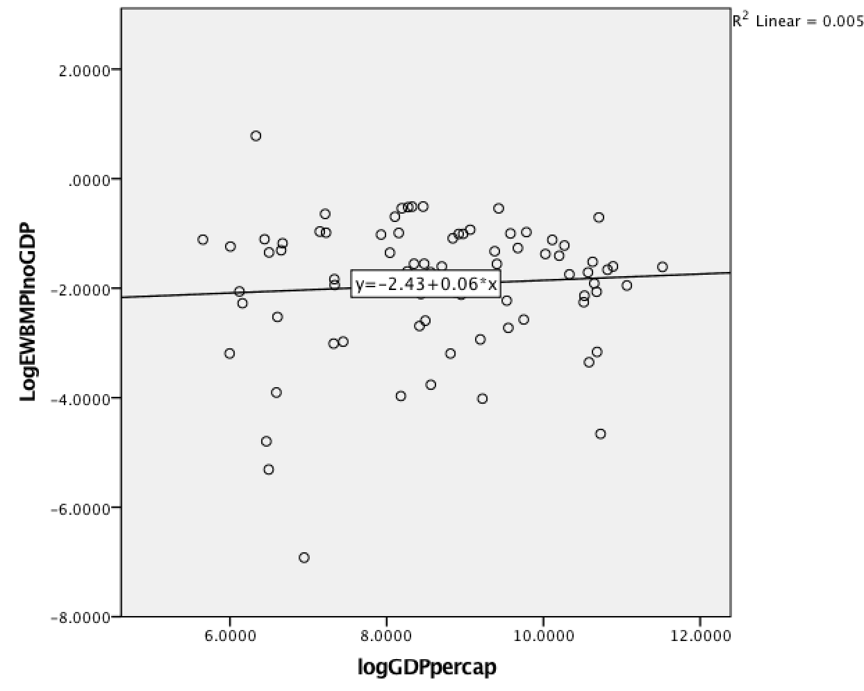

The Graph 1 above consists of log of GDP per capita and Log of BMPI using Equal Weighting method. The index used excludes GDP related variables.

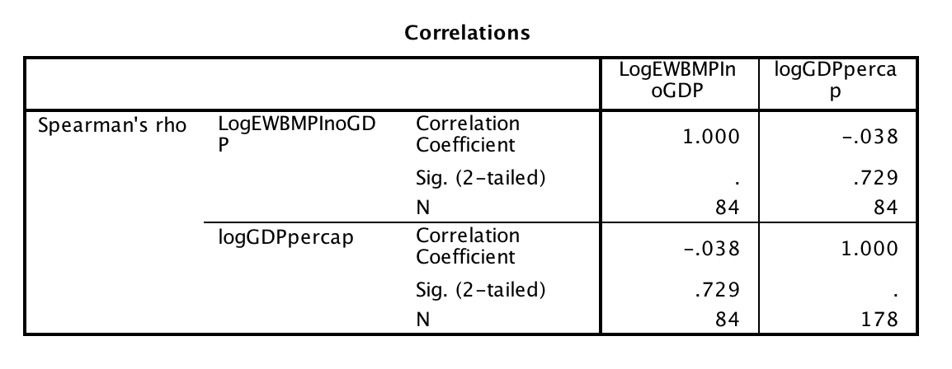

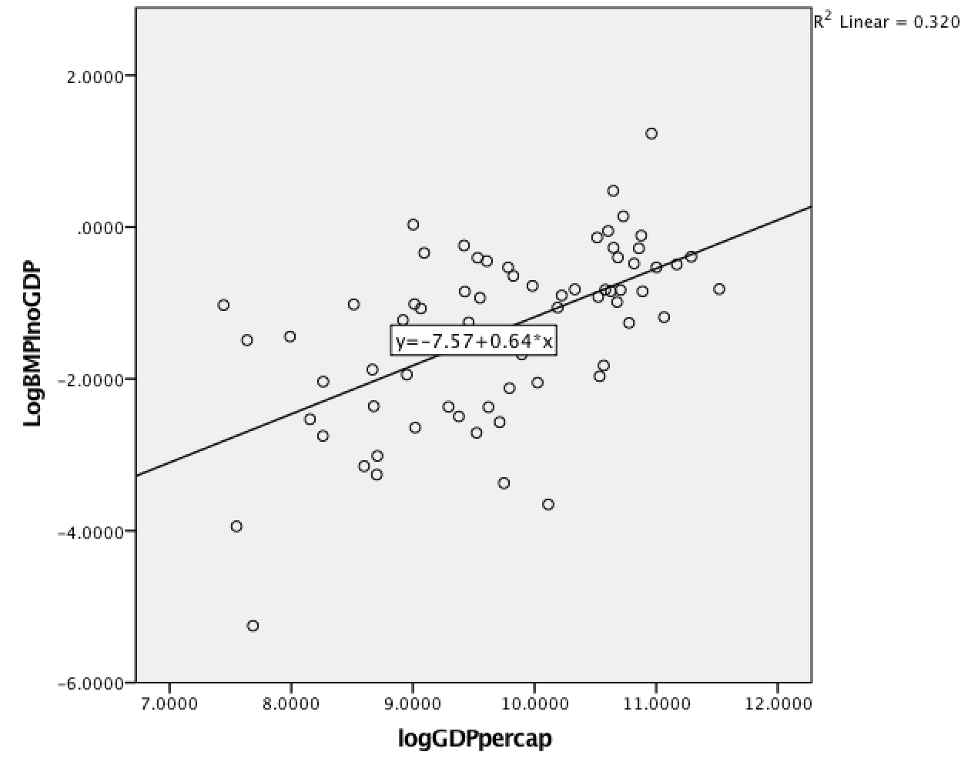

(Graph2)

The graph 2 above shows relationship between log of GDP per capita and Log of BMPI using Principal Component Analysis method. The index used also excludes GDP related variables.

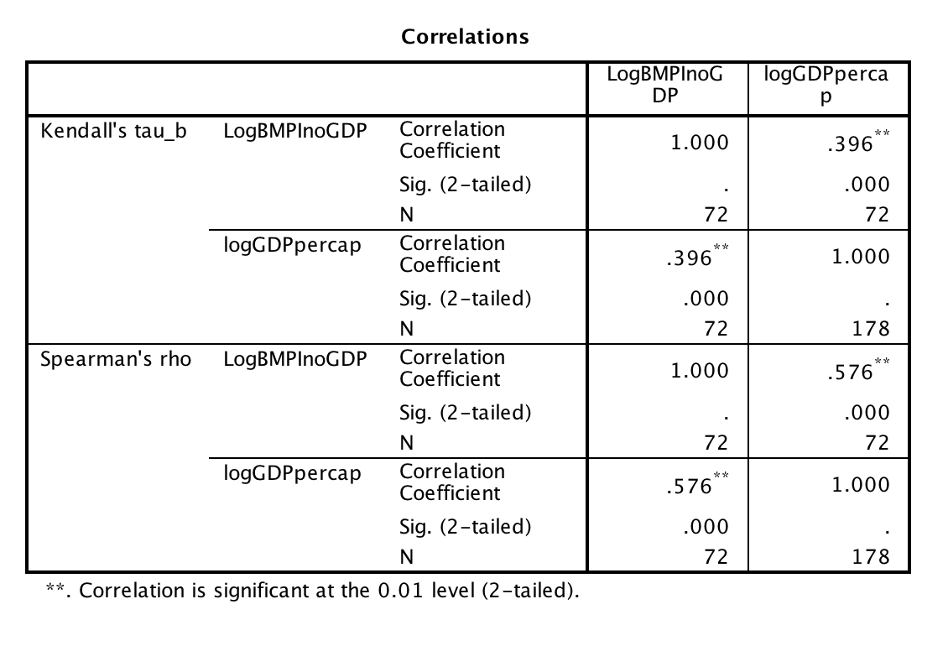 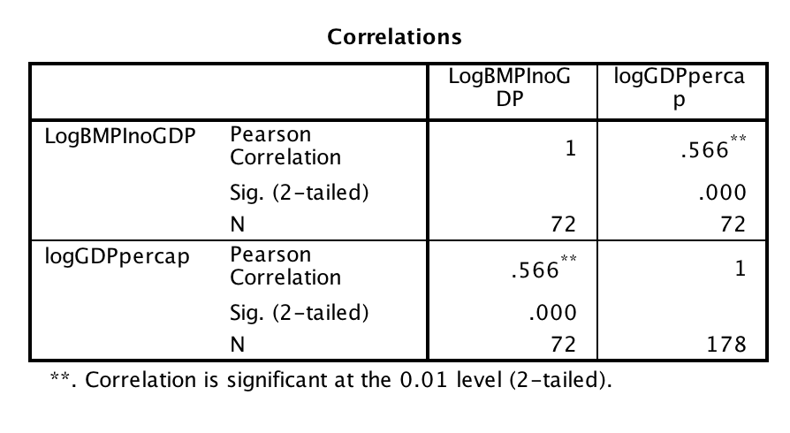

6.4 Findings

From the scatterplot of Graph 1 above, BMPI(EW)and income factor appears to have little to no correlation and yield statistically insignificant result based on p-value. However, as shown is Graph 2, BMPI using PCA method has a strong positive correlation with GDP per capita, and p-value is statistically significant based on computation of Pearson’s, Kendall’s Tau and Spearman’s correlation coefficients.

As a result, it is suggested that people in high income countries are more likely to adopt bitcoin or bitcoin adoption is more likely to gain momentum in high income countries. While the causality between both variables remains unclear, the result largely reflects the reality as Bitcoin behaves more like a luxury for speculative investment rather than a global currency for now. (Yermack, 2014)

6.5 Limitations and Challenges faced by Bitcoin

Blockchain adoption is not without its challenges. There are four major problems that need to be solved in order to gain real traction among public and finance technology industry.

Scalability and Price Volatility

Due to the constraint of block size and finite number of miners on the network, the transaction confirmation time and network fee can spike up easily when the bitcoin network is congested as shown in chart below.

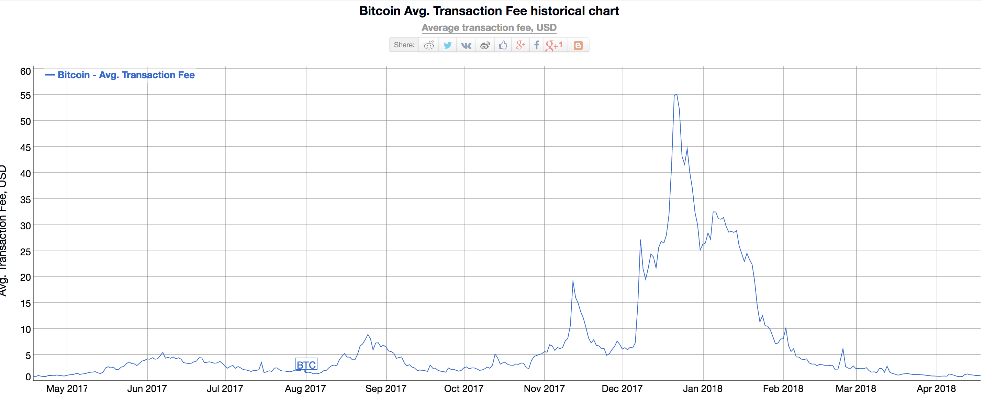

The chart above shows the average transaction fee in the period of May of 2017 to April of 2018.

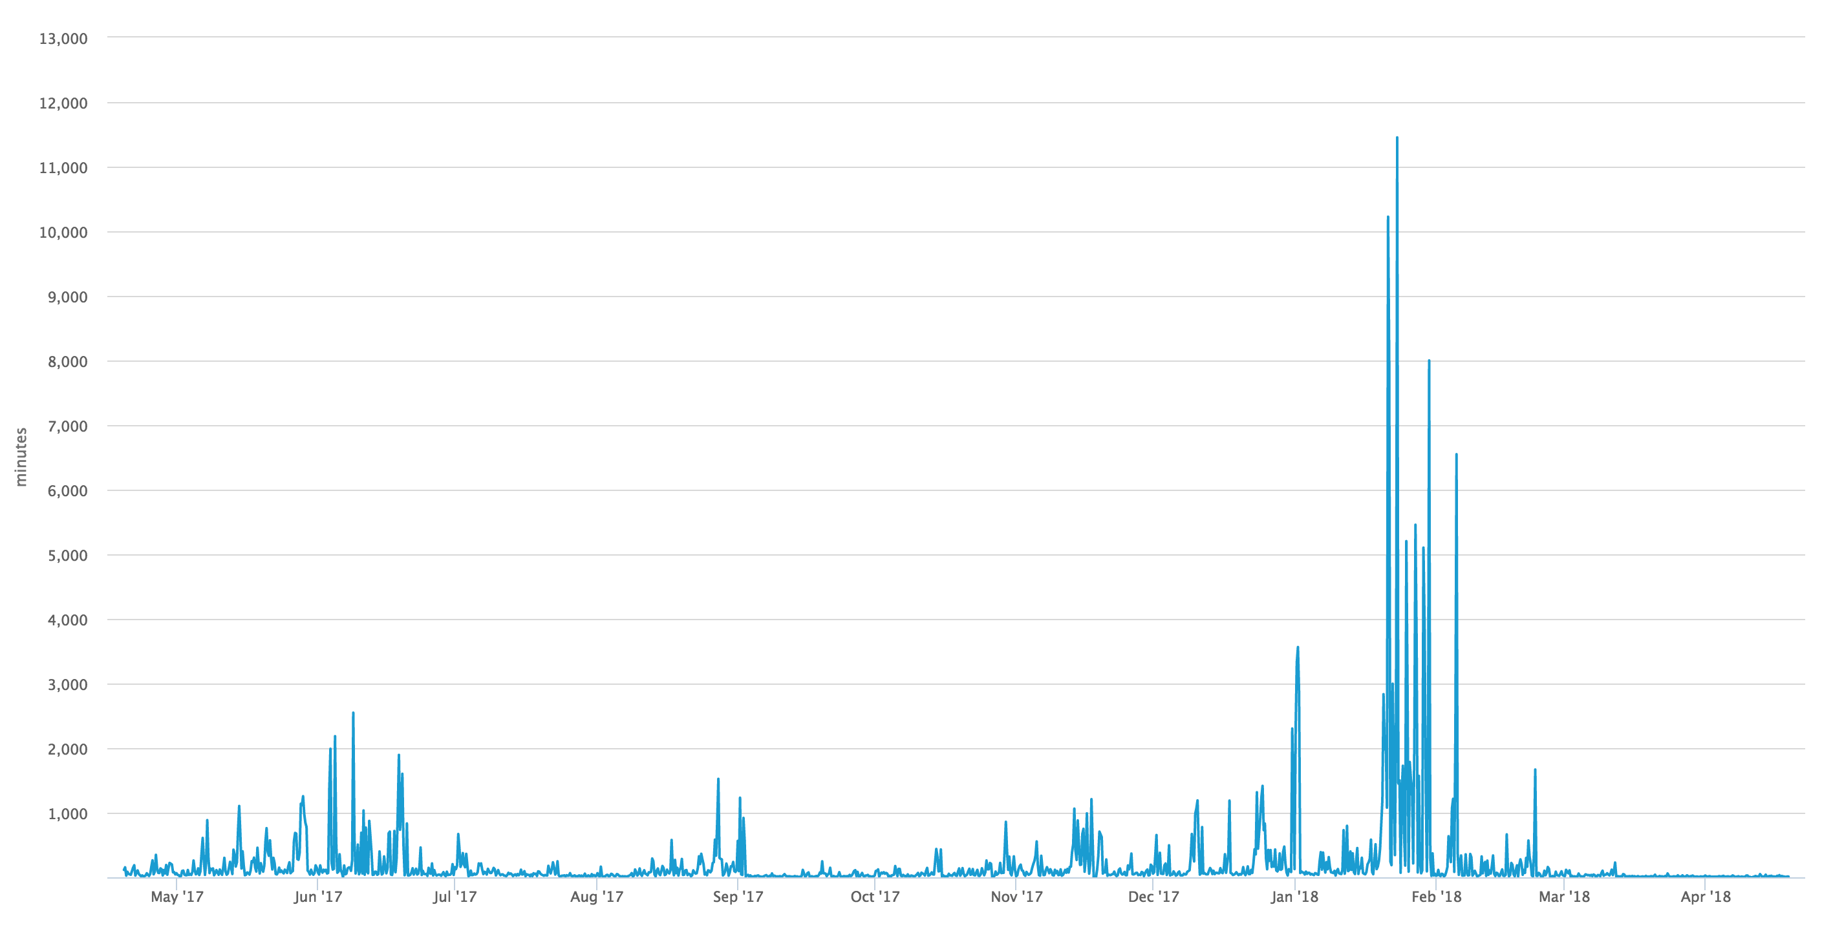

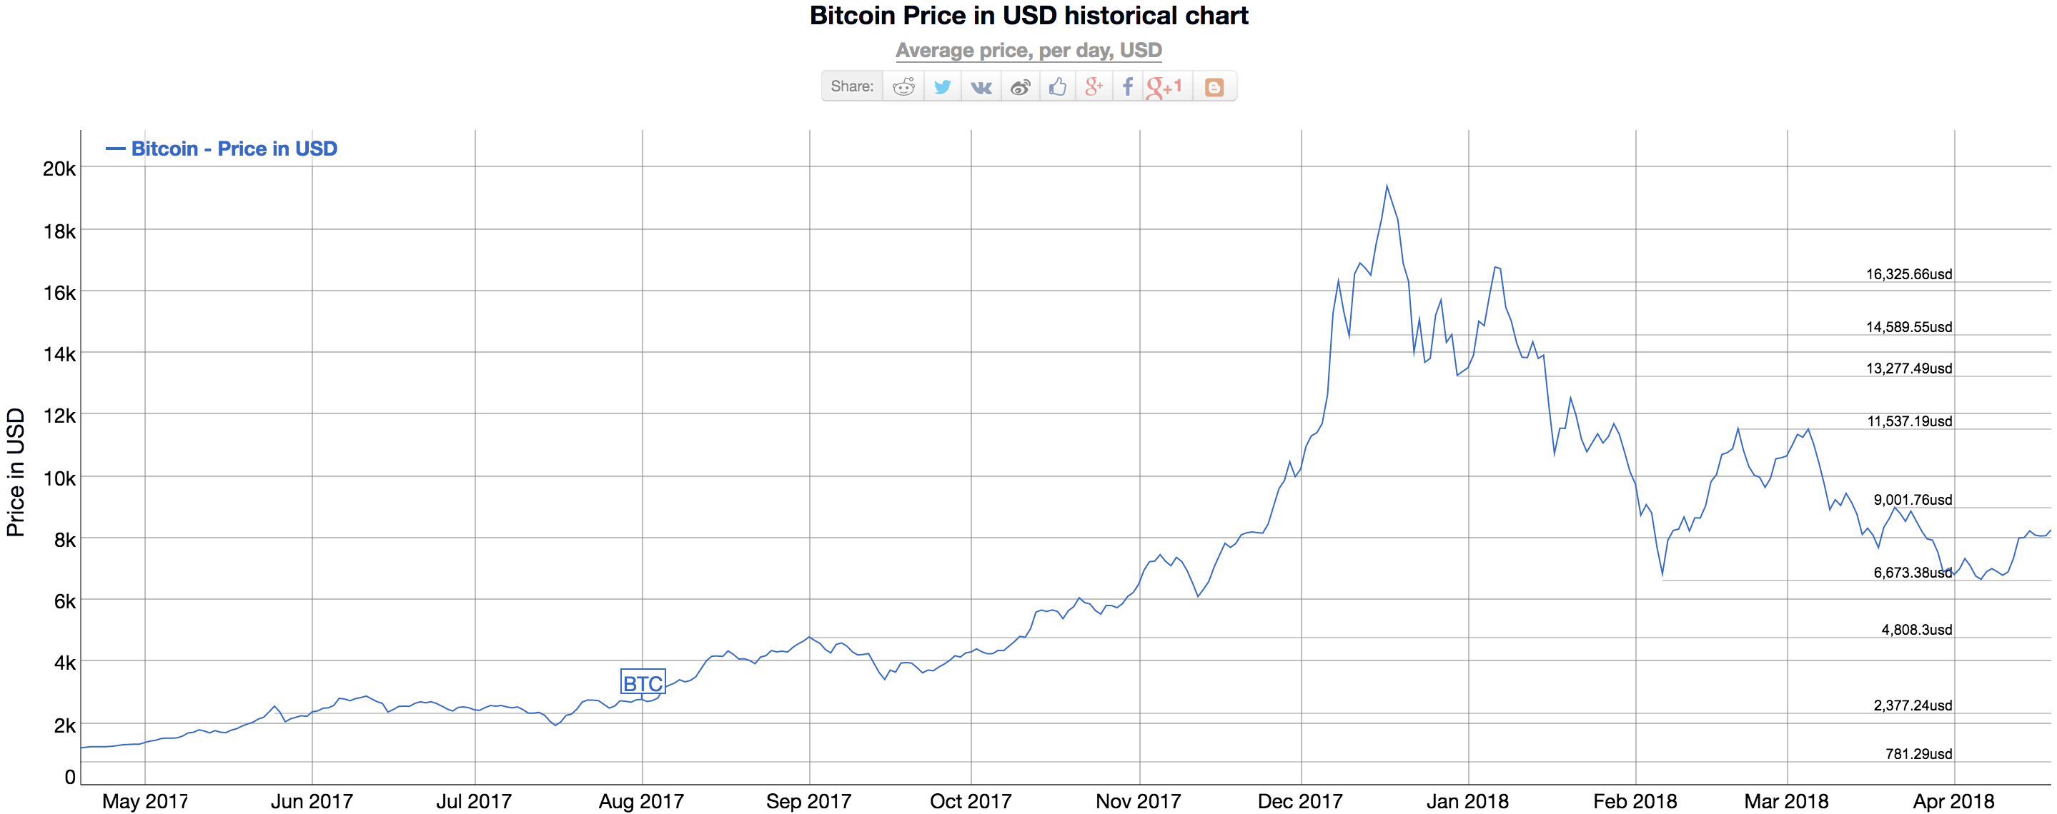

As implied from the charts[2] above, the price volatility is strongly correlated with the transaction fee. Although transaction fee returns to normal rate of 1 US dollar per transaction in 2018, the graph clearly shows that the transaction fee can rise rapidly especially when the bitcoin price was at historical high. The transaction confirmation time can also be painfully slow at times as opposed to bitcoin’s claim of faster and cheaper payment.

Competition

While the number of blockchain based startups continues to grow steadily over the years, almost none of them has risen to the challenge after the hype. For instance, Abra is a blockchain based remittance startup which was initially perceived as potential game changer in remittance industry. However, the fierce competition in the industry including traditional remittance company such as Western Union and MoneyGram and the likes of new FinTech non-blockchain based startup including WorldRemit, Transfer Wise and Remitly eventually drove Abra out of business. Abra has now pivoted its business from the original pitch of helping the unbanked population to becoming a digital wallet app for cryptocurrency investment.

Regulation and Compliance issue

The biggest challenge will be the regulation issue. As the enforcement of know your customer(KYC) and anti-money laundering (AML) remain ambiguous for the cases of cryptocurrency, legal compliance of cross-border remittance proved to be challenging for blockchain-based startups and Bitcoin. This is also the major reason why established company such as Western Union (WU) takes “Wait and See” approach in implementation of blockchain in the business. From the perspective of WU, the anonymity and potential problems of cryptocurrencies have outweighed the benefit brought by digital ledger technology. Nonetheless, Western Union has actively invested in the development of blockchain-based technologies throughout the years.

Deflationary pressure

As there will be only be theoretically 21 million bitcoin supply, the scarcity will drive up the Bitcoin price and it eventually causes the deflationary spiral. The impact can be detrimental for the economy as it disincentivizes the general demand from consumers and output from producers. However, this is based on the assumption that people use solely Bitcoin as replacement of fiat currency in the future. The emergences of other cryptocurrencies such as Ripple and Ethereum makes this statement questionable and thus requires further discussion.

**7. Conclusion**

In this paper, Bitcoin Market Potential Index is calculated using the two different weighting methods, namely Equal Weighting and Principal Components Analysis. This paper also represents the first attempt in constructing and comparing the differences between indices.

The detailed documentation of constructing BMPI using Principal Component Analysis may prove helpful for others to scrutinize the computation process and ensure the transparency in constructing index. The results of BMPI across 178 countries using different weighting approaches are compiled in the Appendix. BMPI aims to serve as reference for public in identifying which countries are more conducive to bitcoin adoptions.

In search of understanding relationship between potential utility of bitcoin and income variable, the correlation analysis is carried out between BMPI and GDP per capita in logarithmic scale. The result shows that BMPI is positively and strongly correlated to GDP per capita.

In short, the research questions of this thesis were successfully addressed through a variety of weighting methods. While the weighting of variables is essentially dependent on the subjective opinion or statistical method of analyst, the information presented in this work could be useful for investors, regulators, governments, private companies and academics that are interested in the primary factors of bitcoin adoption in certain countries.

Nonetheless, further research should be done in investigating causal relationship between BMPI and other macroeconomic indicator in the future. As the world of cryptocurrencies continues to evolve rapidly, other alternative cryptocurrencies shall be included to produce a more accurate index.

**References**

Alfonso, A., Langer, P. and Vandelis, Z. (2016). The Future of Cryptocurrency: An Investor’s Comparison of Bitcoin and Ethereum.

Baur, D., Hong, K. and Lee, A. (2017). Bitcoin: Medium of Exchange or Speculative Assets?.

Bohme, S. (2014). Analysis of Bitcoin as a Peer-to-Peer Network for International Payments.

Ciaian, P., Rajcaniova, M., and Kancs, A. (2014). The economics of bitcoin price formation. Technical report. http:// arxiv.org/pdf/1405.4498.

Davies, D. (2014). *The curious case of Bitcoin: Is Bitcoin volatility driven by online research?* PhD thesis, University of Victoria. http://[www.uvic.ca/socialsciences/economics/assets/docs/honours/Davies1.pdf](http://www.uvic.ca/socialsciences/economics/assets/docs/honours/Davies1.pdf).

Hileman, G. (2014). The Bitcoin Market Potential Index. *SSRN Electronic Journal*.

Mazer, T. (2015). Bitcoin: A worldwide currency?.

Moore, W. and Stephen, J. (2015). Should Cryptocurrencies Be Included in the Portfolio of International Reserves Held by the Central Bank of Barbados?. *SSRN Electronic Journal*.

Nardo, Michela, Michaela Saisana, Andrea Saltelli, Stefano Tarantola, Anders Hoffman, and Enrico Giovannini. 2005. Handbook on constructing composite indicators: methodology and user guide. OECD publishing.

Oguz Oztunali, C. (2012). Shadow Economies around the World: Model Based Estimates∗.

Reinhart, C. and Rogoff, K. (2010). Growth in a Time of Debt. *American Economic Review*, 100(2), pp.573-578.

Soldevilla, J. (2017). Analyzing Bitcoin Price Volatility.

Viglione, R. (2015). Does Governance Have a Role in Pricing? Cross-Country Evidence from Bitcoin Markets. *SSRN Electronic Journal*.

Yermack, D. (2013). Is Bitcoin a Real Currency? *SSRN Electronic Journal*.

**Appendix A** : Hileman’s BMPI Ranking in 2014 using Equal Weighting (EW)

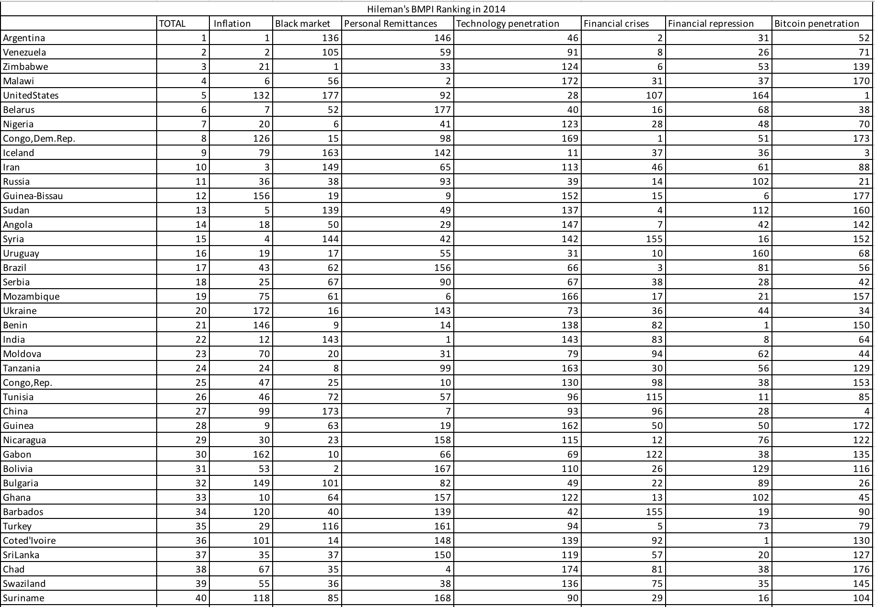

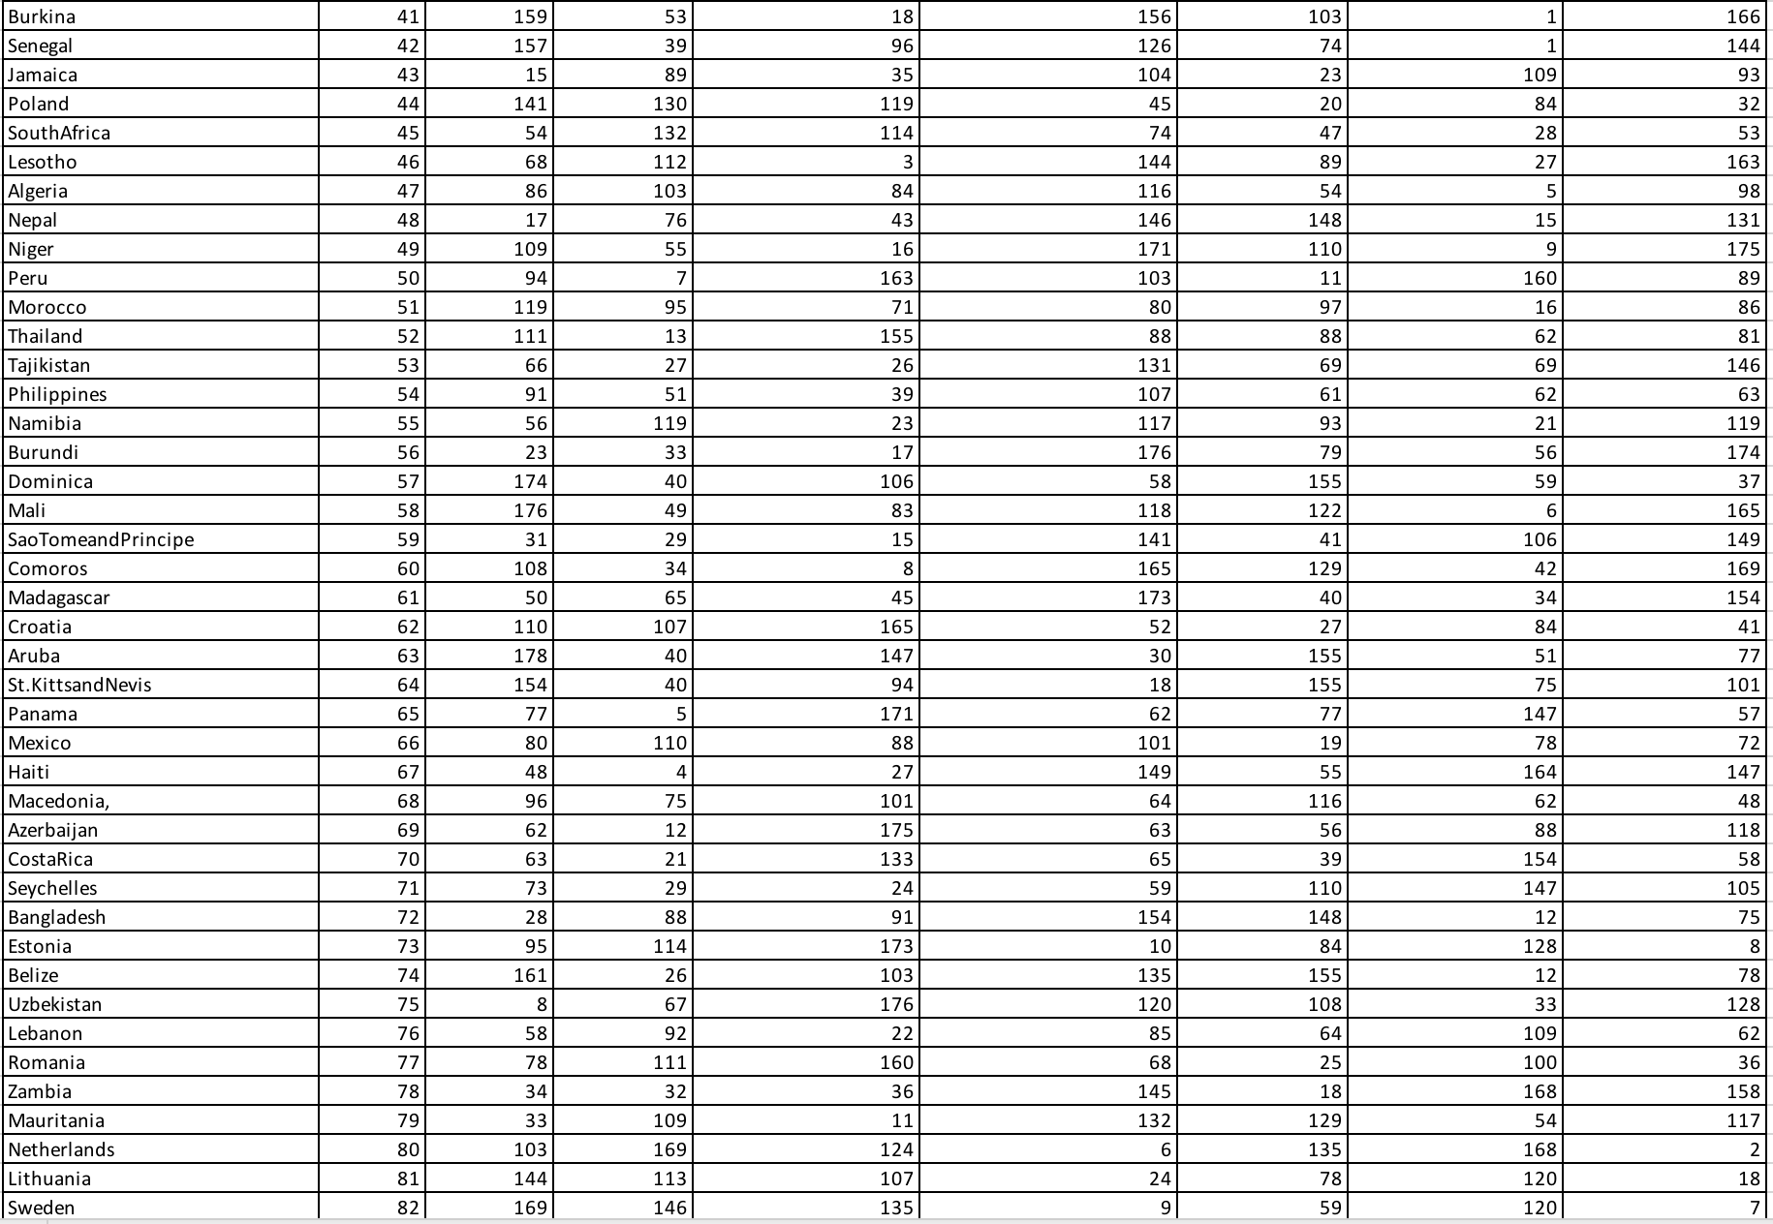

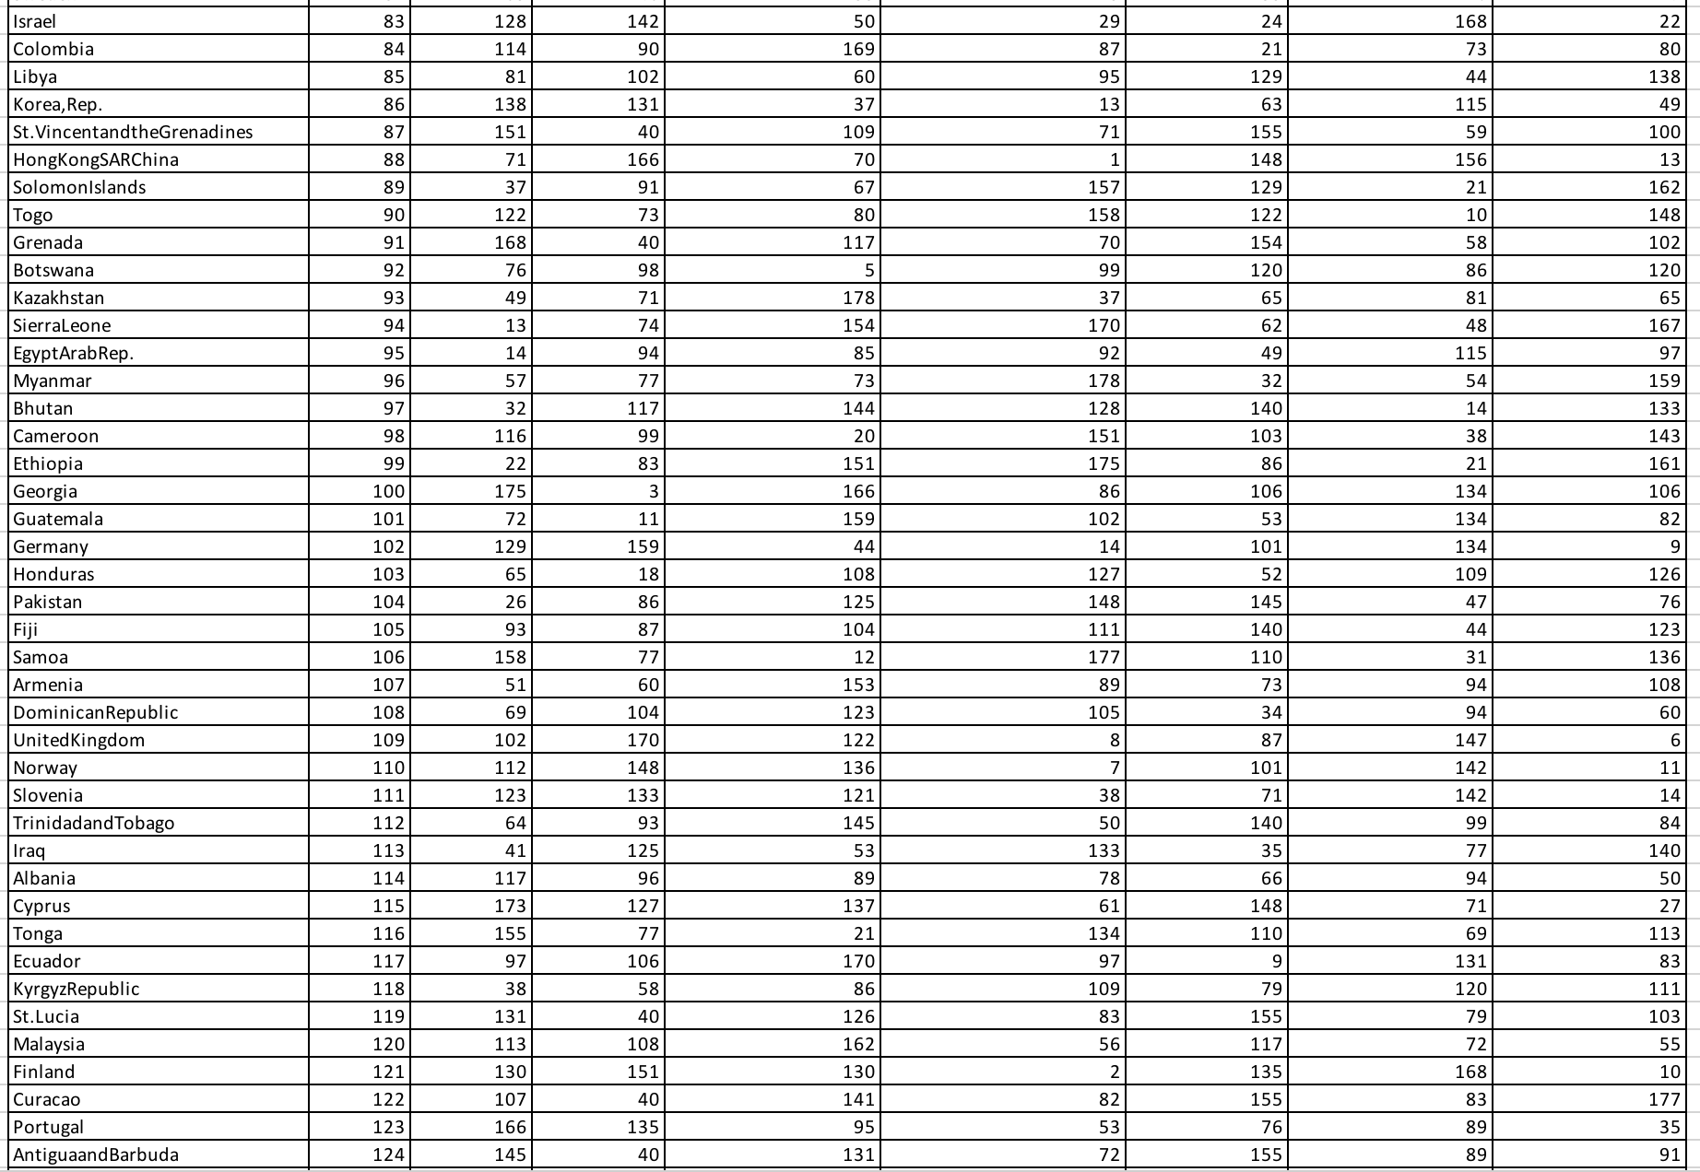

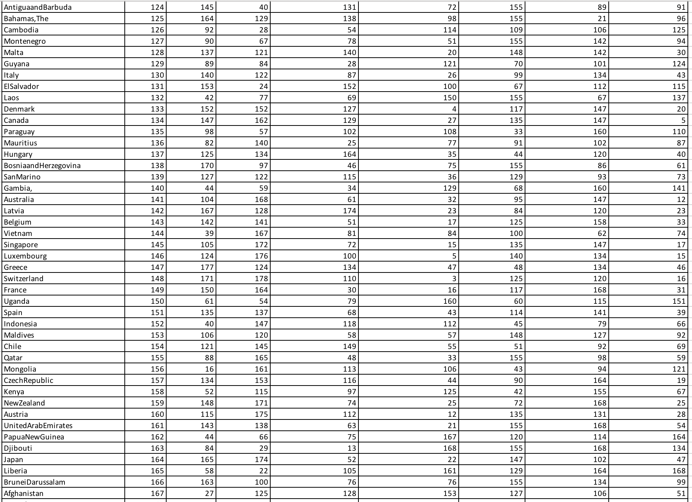

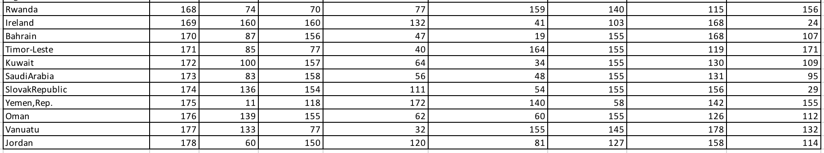

**Appendix B**: BMPI in 2018 using Equal Weighting (EW)

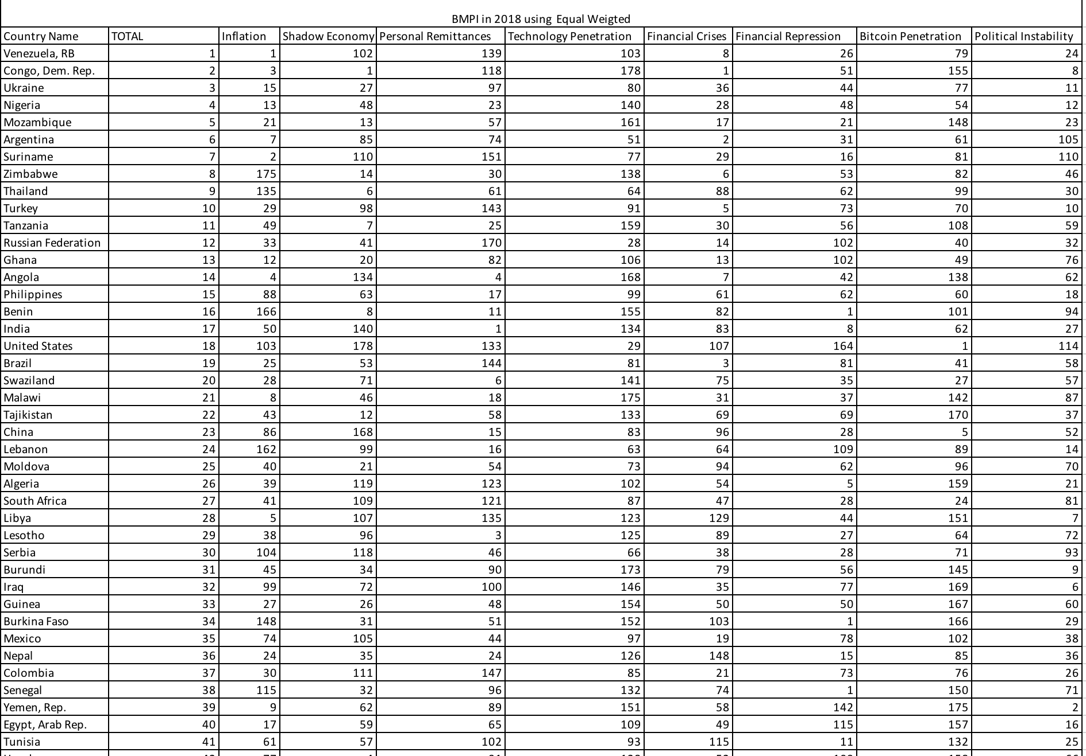

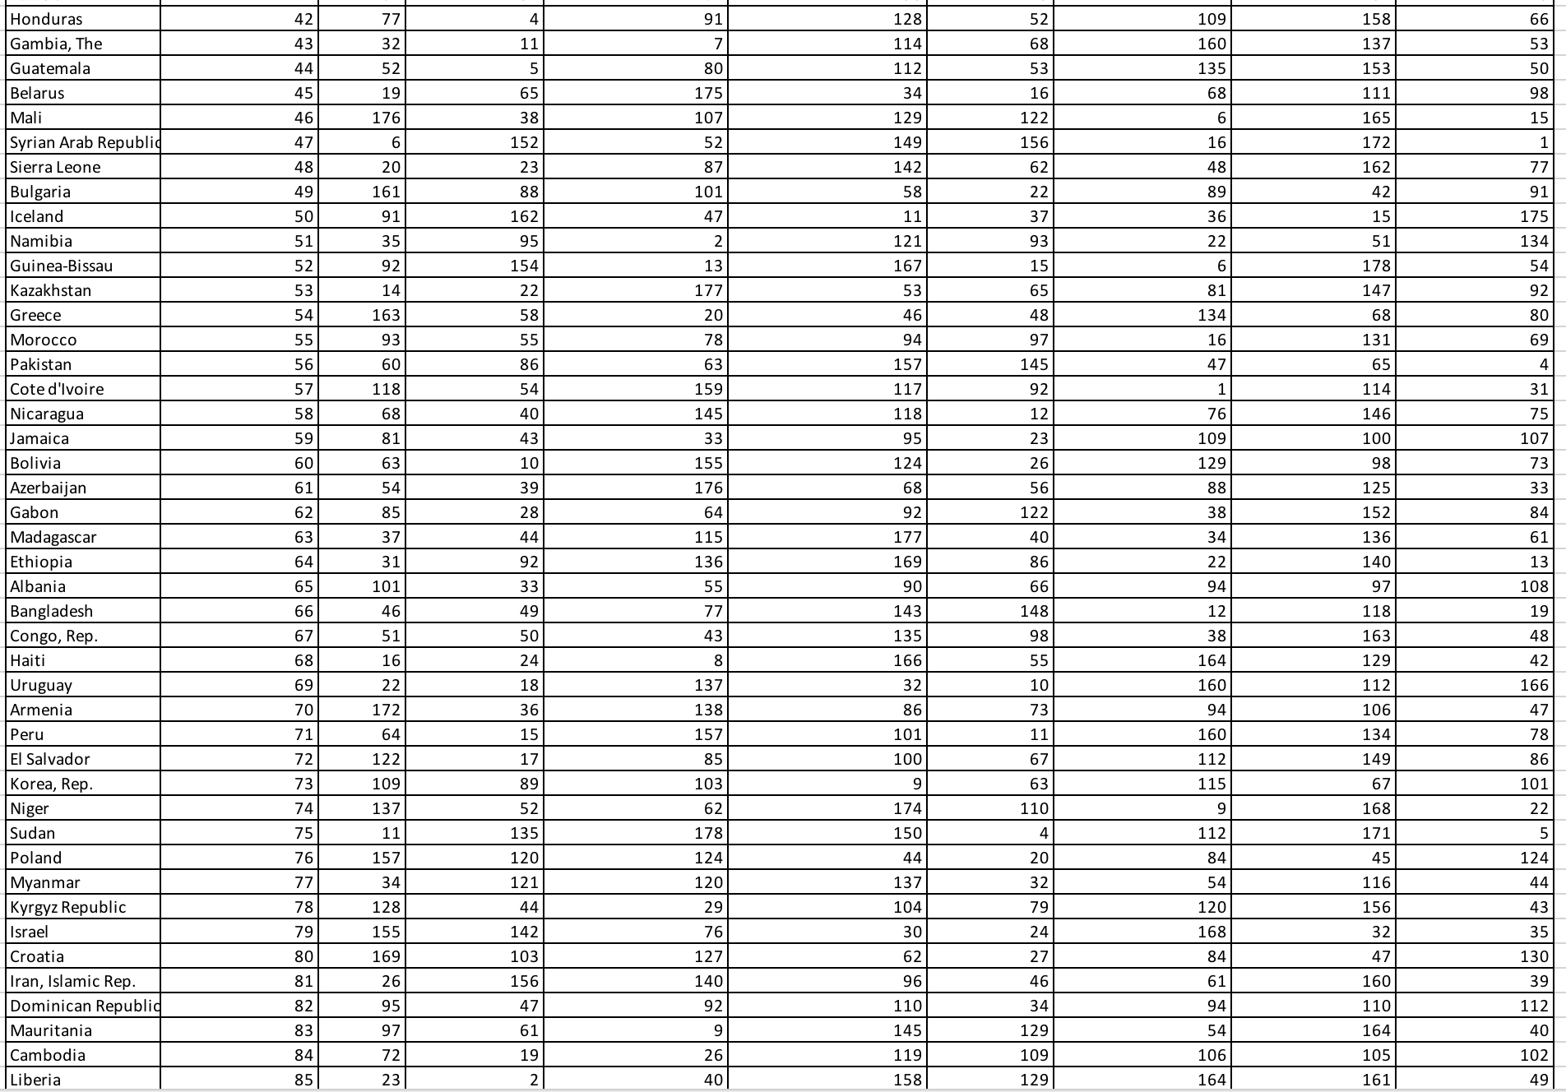

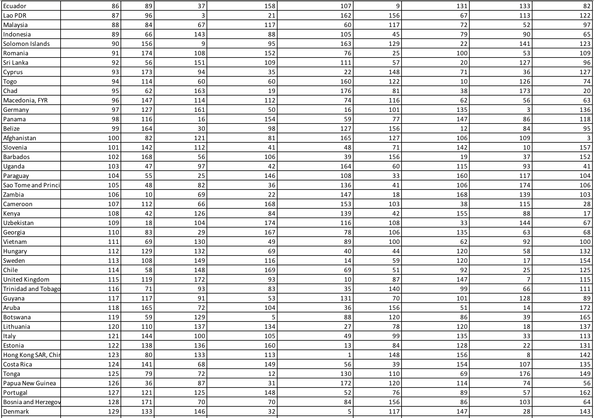

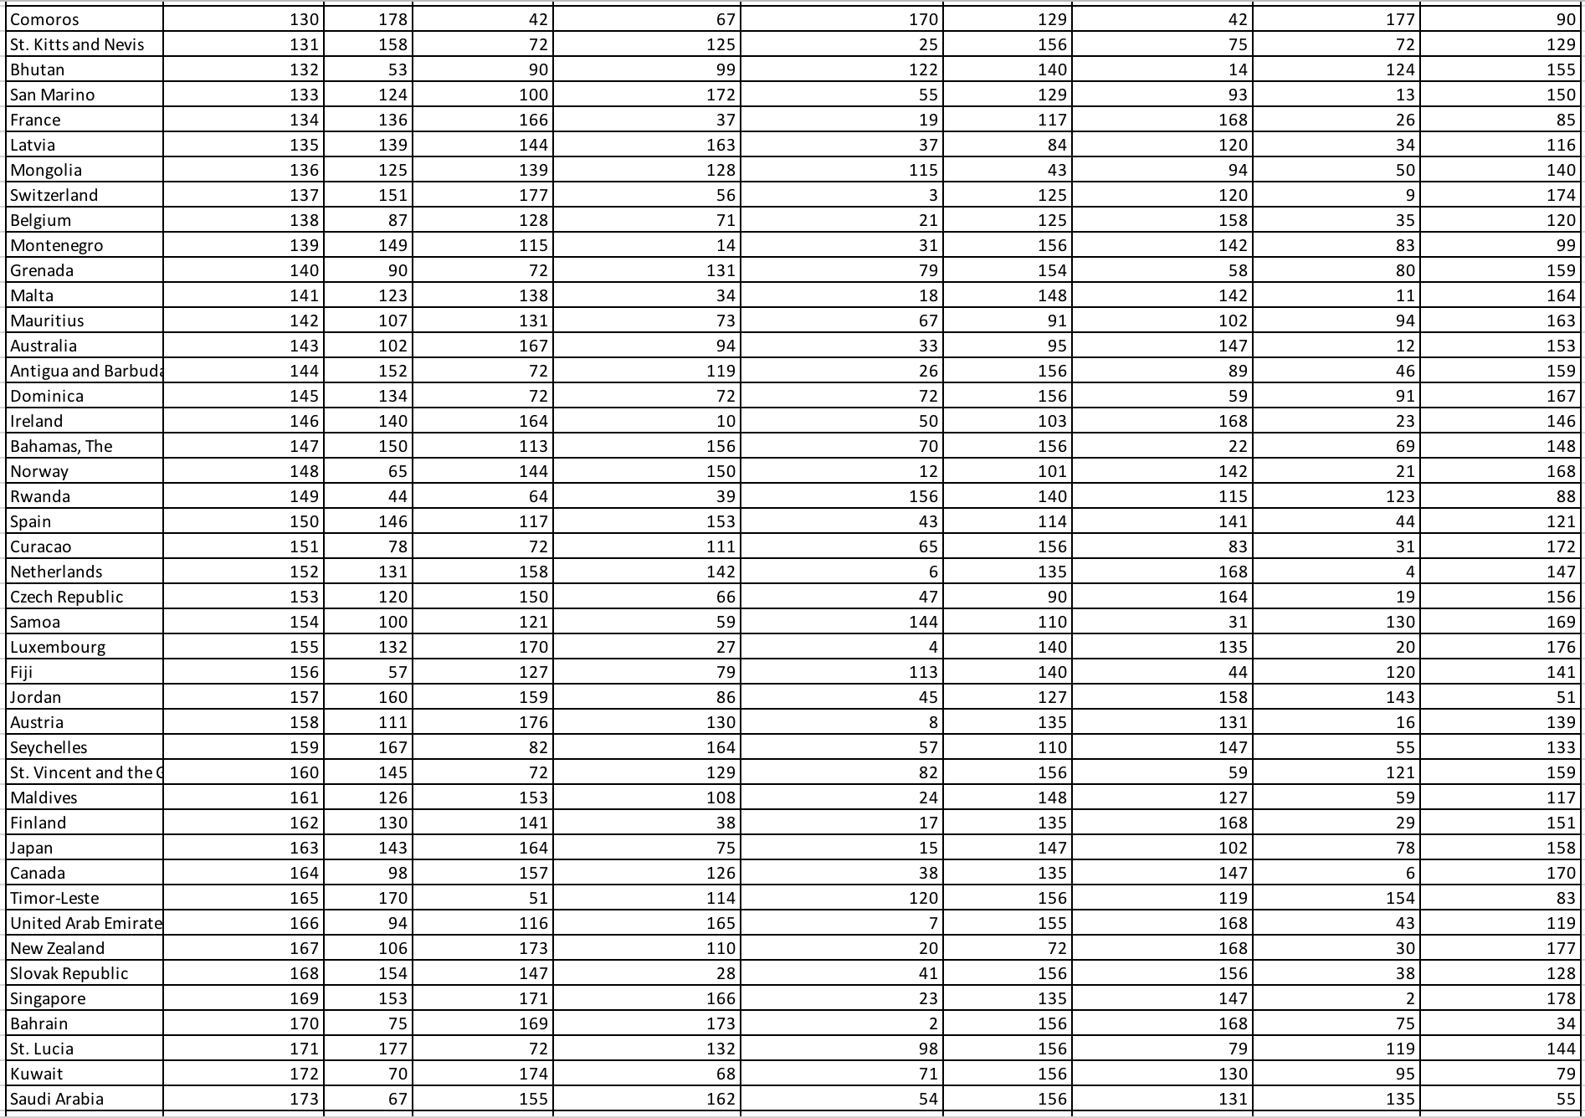



**Appendix C**: BMPI in 2018 using Principal Component Analysis (PCA)

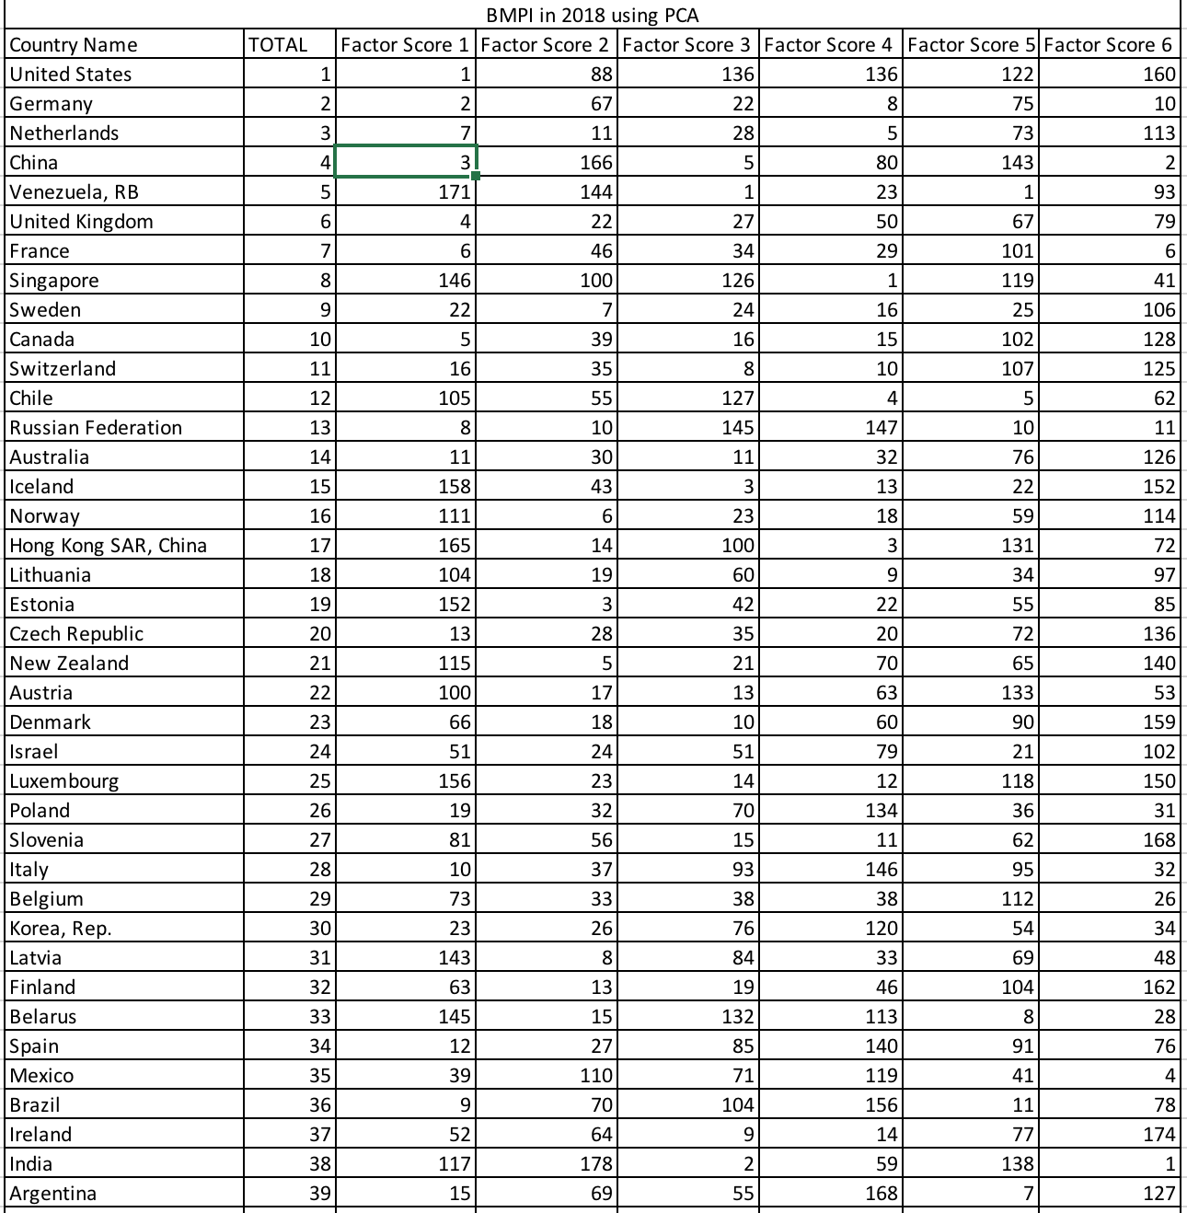

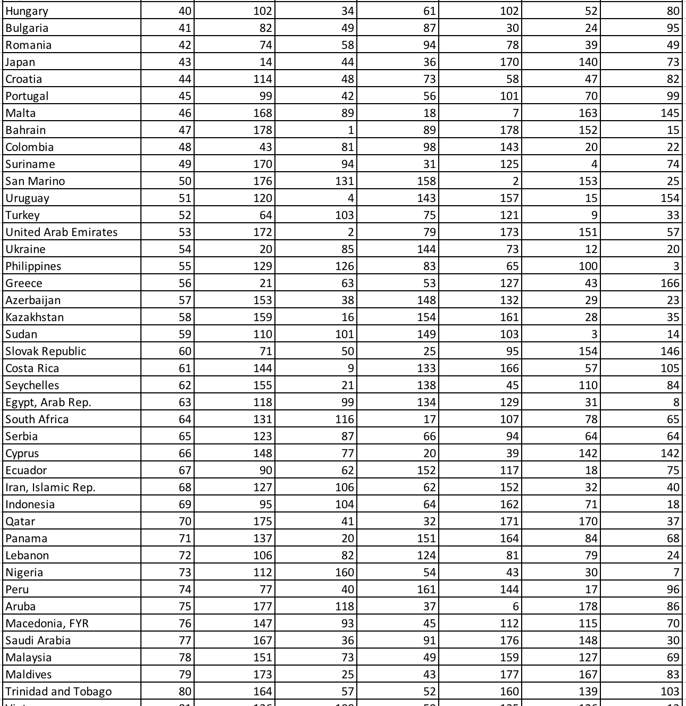

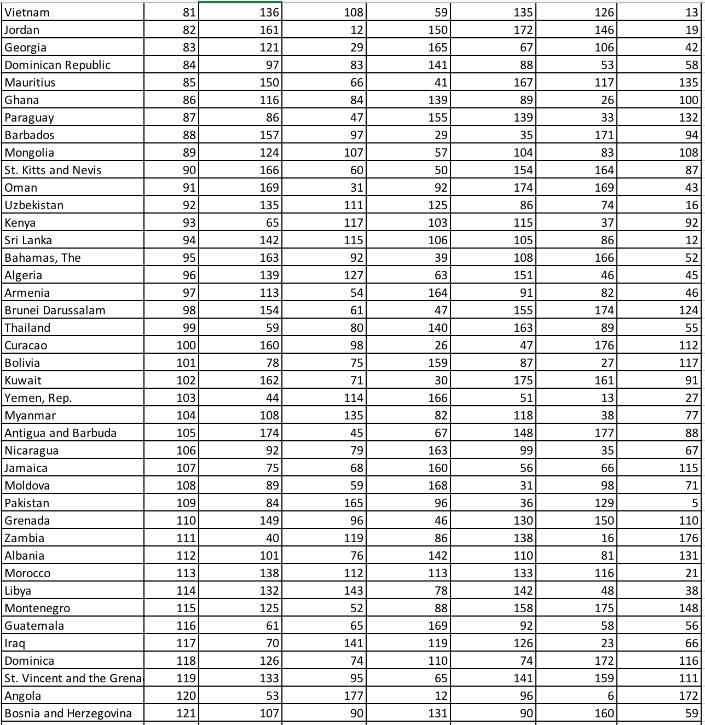

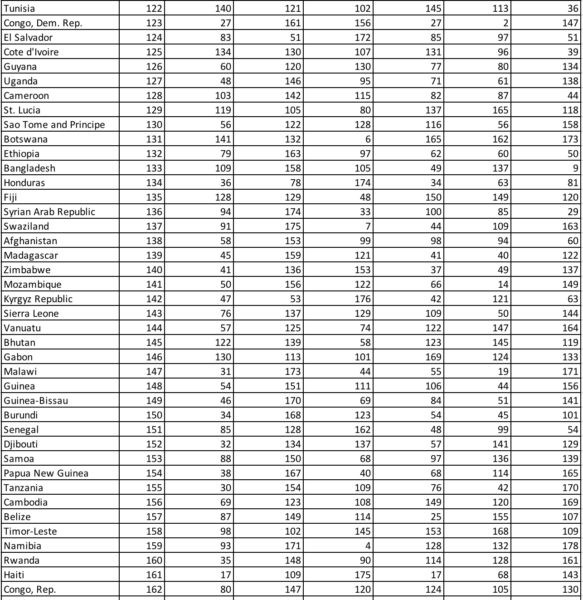

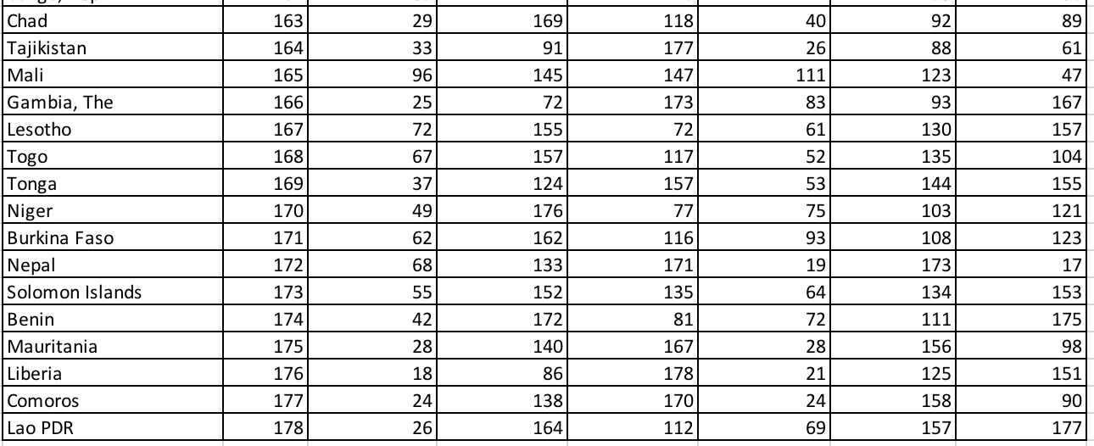

1. Bitcoin is not entirely anonymous and untraceable in the sense that it is possible to link one identity with his public key as all Bitcoin transactions are publicly logged.
2. The chart at the upper side shows the average transaction time waiting for first confirmation.